Table of Contents

UNITED STATES

SECURITIES AND EXCHANGE COMMISSION
Washington, D.C. 20549

SCHEDULE 14A

Proxy Statement Pursuant to Section 14(a) of the
Securities Exchange Act of 1934
(Amendment No. )

Filed by the Registrant ☒

Filed by a party other than the Registrant ☐

Check the appropriate box:

- Preliminary Proxy Statement

- Confidential, for Use of the Commission Only (as permitted by Rule 14a-6(e)(2))

- Definitive Proxy Statement

- Definitive Additional Materials

- Soliciting Material Pursuant to §240.14a-12

Xometry, Inc.

(Name of Registrant as Specified In Its Charter)

(Name of Person(s) Filing Proxy Statement, if Other Than The Registrant)

Payment of Filing Fee (Check the appropriate box):

- No fee required.

- Fee paid previously with preliminary materials.

- Fee computed on table in exhibit required by Item 25(b) per Exchange Act Rules 14a-6(i)(1) and 0-11.

Table of Contents
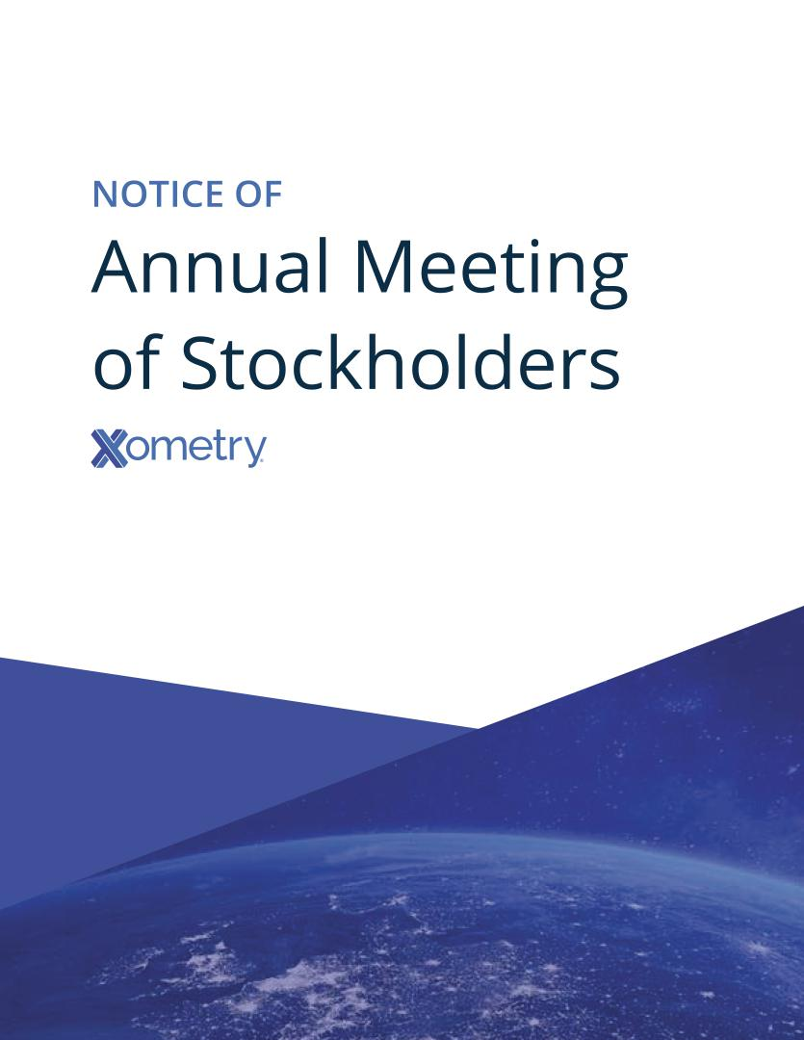

Table of Contents


May 2, 2022

Dear Fellow Stockholders:

As we celebrate our successes in 2021, we also reflect on the unprecedented circumstances that are shaping our world.

The global events that have crippled supply chains, spurred product shortages and limited access to raw materials further underscore the need for the rapid digital transformation of the manufacturing industry. Our AI-driven global marketplace is playing an instrumental role in helping buyers create locally resilient supply chains and manufacturers grow their businesses. Through our marketplace we are unleashing the power of innovation. We are a strategic asset to companies that are pushing the world forward creating the products and services that will define our collective future including autonomous and electric vehicles, clean energy technology, robotics, space exploration, next-generation medical devices and more.

We are proud of what we’ve accomplished in 2021, and our team continues to work diligently to deliver comprehensive solutions that benefit buyers and suppliers.

Accordingly, I invite you to attend the 2022 Annual Meeting of Stockholders of Xometry, Inc., a Delaware corporation (“Xometry”) to be held virtually on June 28, 2022 at 11:00 AM Eastern Time. As part of our precautions regarding the ongoing COVID-19 pandemic and to support the health and well-being of our stockholders as well as providing expanded access from locations around the world and lowering costs, we have adopted a virtual format for our 2022 Annual Meeting, which will be held solely online via live webcast.

You will be able to attend the Annual Meeting, ask your questions and vote your shares during the meeting by visiting https://meetnow.global/MM6NC9R (please note that Internet Explorer is not supported) and entering the control number located on the Notice of Internet Availability of Proxy Materials for the 2022 Annual Meeting of Stockholders, your proxy card or voting instruction form. Additional details regarding access to the Annual Meeting and the business to be conducted at the Annual Meeting are described in the accompanying Notice of 2022 Annual Meeting of Stockholders and proxy statement.

We have elected to provide access to our proxy materials over the Internet under the U.S. Securities and Exchange Commission’s “notice and access” rules. As a result, we are mailing to our stockholders a Notice of Internet Availability of Proxy Materials instead of paper copies of the proxy statement and our 2021 Annual Report. The notice contains instructions on how to access those documents over the Internet. The Notice of Internet Availability of Proxy Materials also contains instructions on how stockholders can receive a paper copy of our proxy materials, including the proxy statement, our 2021 Annual Report and a form of proxy card or voting instruction form. We believe that providing our proxy materials over the Internet increases the ability of our stockholders to connect with the information they need, while reducing the environmental impact and cost of our Annual Meeting.

Your vote is important. Regardless of whether you plan to attend the Annual Meeting, we hope you will vote as soon as possible. You may vote over the Internet, by telephone or, if you receive a paper proxy card by mail, by completing and returning the proxy card or voting instruction form mailed to you. Please carefully review the instructions on each of your voting options described in this proxy statement, as well as in the Notice of Internet Availability of Proxy Materials you received in the mail.

Table of Contents

On behalf of the Xometry Board of Directors and employees, we thank you for your continued support and look forward to speaking with you at the Annual Meeting.

Sincerely,
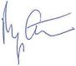

Randy Altschuler

Chief Executive Officer

Table of Contents

XOMETRY, INC.

7529 Standish Place

Suite 200

Derwood, Maryland 20855

NOTICE OF 2022 ANNUAL MEETING OF STOCKHOLDERS

Date:

June 28, 2022

Time:

11:00 AM Eastern Time

Location:

The Annual Meeting can be accessed by visiting https://meetnow.global/MM6NC9R (please note that Internet Explorer is not supported) and entering your control number included in the Notice of Internet Availability of Proxy Materials.

Record Date:

The record date for the Annual Meeting is May 4, 2022. Only stockholders of record at the close of business on that date may vote at the Annual Meeting or any adjournment thereof. Further information regarding voting rights and the matters to be voted upon is presented in the accompanying proxy statement.

Items of Business:

The Annual Meeting will be held for the following purposes, which are more fully described in the proxy statement accompanying this Notice:

(1) To elect the two nominees named in the attached proxy statement as directors to serve on the Board of Directors for a three-year term.

(2) To ratify the selection of KPMG LLP as our independent registered public accounting firm for the fiscal year ending December 31, 2022.

(3) To conduct any other business properly brought before the meeting or any adjournment or postponement thereof.

Your vote is important. Whether or not you expect to attend the virtual Annual Meeting, please vote by telephone or through the Internet, or, if you receive a paper proxy card by mail, by completing and returning the proxy card mailed to you, as promptly as possible to ensure your representation at the Annual Meeting. Voting instructions are provided in the Notice of Internet Availability of Proxy Materials, or, if you receive a paper proxy card by mail, the instructions are printed on your proxy card and included in the accompanying Proxy Statement. Even if you have voted by proxy, you may still vote online during the Annual Meeting. Please note, however, that if your shares are held of record by a brokerage firm, bank or other agent and you wish to vote online at the Annual Meeting, you must obtain a proxy issued in your name from that agent to vote your shares that are held in such agent’s name and account.

Sincerely,
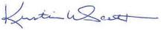

Kristie Scott

General Counsel and Secretary

Derwood, Maryland

May 2, 2022

Table of Contents

 |  |  |  |  |  |  |  |  |  |  |  |  |  |  |  |  |  |  |  |  |  |  |  |  |  |  |  | TABLE OF CONTENTS
 |  |  |  |  |  |  |  |  |  |  |  |  |  |  |  |  |  |  |  |  |  |  |  |  |  |  |  |  |  |  |  |  |  | Page
GENERAL INFORMATION |  |  |  |  |  |  |  |  |  |  |  |  |  |  |  |  |  |  |  |  |  |  |  |  |  |  |  |  |  |  |  |  |  | 1
PROPOSAL 1: ELECTION OF DIRECTORS |  |  |  |  |  |  |  |  |  |  |  |  |  |  |  |  |  |  |  |  |  |  |  |  |  |  |  |  |  |  |  |  |  | 8
 | General |  |  |  |  |  |  |  |  |  |  |  |  |  |  |  |  |  |  |  |  |  |  |  |  |  |  |  |  |  |  |  |  | 8
 | Vote Required |  |  |  |  |  |  |  |  |  |  |  |  |  |  |  |  |  |  |  |  |  |  |  |  |  |  |  |  |  |  |  |  | 8
 | Our Recommendation |  |  |  |  |  |  |  |  |  |  |  |  |  |  |  |  |  |  |  |  |  |  |  |  |  |  |  |  |  |  |  |  | 9
 | Information About Our Continuing Directors |  |  |  |  |  |  |  |  |  |  |  |  |  |  |  |  |  |  |  |  |  |  |  |  |  |  |  |  |  |  |  |  | 9
INFORMATION REGARDING THE BOARD AND CORPORATE GOVERNANCE |  |  |  |  |  |  |  |  |  |  |  |  |  |  |  |  |  |  |  |  |  |  |  |  |  |  |  |  |  |  |  |  |  | 11
 | Board Independence |  |  |  |  |  |  |  |  |  |  |  |  |  |  |  |  |  |  |  |  |  |  |  |  |  |  |  |  |  |  |  |  | 11
 | Leadership Structure and Risk Oversight |  |  |  |  |  |  |  |  |  |  |  |  |  |  |  |  |  |  |  |  |  |  |  |  |  |  |  |  |  |  |  |  | 11
 | Board Diversity |  |  |  |  |  |  |  |  |  |  |  |  |  |  |  |  |  |  |  |  |  |  |  |  |  |  |  |  |  |  |  |  | 12
 | Board Meetings and Attendance |  |  |  |  |  |  |  |  |  |  |  |  |  |  |  |  |  |  |  |  |  |  |  |  |  |  |  |  |  |  |  |  | 12
 | Board Committees |  |  |  |  |  |  |  |  |  |  |  |  |  |  |  |  |  |  |  |  |  |  |  |  |  |  |  |  |  |  |  |  | 13
 | Audit Committee Report |  |  |  |  |  |  |  |  |  |  |  |  |  |  |  |  |  |  |  |  |  |  |  |  |  |  |  |  |  |  |  |  | 17
 | Code of Business Conduct and Ethics |  |  |  |  |  |  |  |  |  |  |  |  |  |  |  |  |  |  |  |  |  |  |  |  |  |  |  |  |  |  |  |  | 17
 | Corporate Governance Guidelines |  |  |  |  |  |  |  |  |  |  |  |  |  |  |  |  |  |  |  |  |  |  |  |  |  |  |  |  |  |  |  |  | 18
 | Stockholder Communications with the Board |  |  |  |  |  |  |  |  |  |  |  |  |  |  |  |  |  |  |  |  |  |  |  |  |  |  |  |  |  |  |  |  | 18
 | Hedging Policy |  |  |  |  |  |  |  |  |  |  |  |  |  |  |  |  |  |  |  |  |  |  |  |  |  |  |  |  |  |  |  |  | 18
PROPOSAL 2: RATIFICATION OF THE SELECTION OF THE INDEPENDENT REGISTERED PUBLIC ACCOUNTING FIRM |  |  |  |  |  |  |  |  |  |  |  |  |  |  |  |  |  |  |  |  |  |  |  |  |  |  |  |  |  |  |  |  |  | 19
 | Vote Required |  |  |  |  |  |  |  |  |  |  |  |  |  |  |  |  |  |  |  |  |  |  |  |  |  |  |  |  |  |  |  |  | 19
 | Independent Registered Public Accounting Firm Fees |  |  |  |  |  |  |  |  |  |  |  |  |  |  |  |  |  |  |  |  |  |  |  |  |  |  |  |  |  |  |  |  | 19
 | Pre-Approval Policies and Procedures |  |  |  |  |  |  |  |  |  |  |  |  |  |  |  |  |  |  |  |  |  |  |  |  |  |  |  |  |  |  |  |  | 19
 | Our Recommendation |  |  |  |  |  |  |  |  |  |  |  |  |  |  |  |  |  |  |  |  |  |  |  |  |  |  |  |  |  |  |  |  | 20
EXECUTIVE OFFICERS |  |  |  |  |  |  |  |  |  |  |  |  |  |  |  |  |  |  |  |  |  |  |  |  |  |  |  |  |  |  |  |  |  | 21
EXECUTIVE OFFICER AND DIRECTOR COMPENSATION |  |  |  |  |  |  |  |  |  |  |  |  |  |  |  |  |  |  |  |  |  |  |  |  |  |  |  |  |  |  |  |  |  | 22
 | Executive Officer Compensation |  |  |  |  |  |  |  |  |  |  |  |  |  |  |  |  |  |  |  |  |  |  |  |  |  |  |  |  |  |  |  |  | 22
 | Narrative to the Summary Compensation Table |  |  |  |  |  |  |  |  |  |  |  |  |  |  |  |  |  |  |  |  |  |  |  |  |  |  |  |  |  |  |  |  | 22
 | Employment Arrangements |  |  |  |  |  |  |  |  |  |  |  |  |  |  |  |  |  |  |  |  |  |  |  |  |  |  |  |  |  |  |  |  | 24
 | Health and Welfare and Retirement Benefits; Perquisites |  |  |  |  |  |  |  |  |  |  |  |  |  |  |  |  |  |  |  |  |  |  |  |  |  |  |  |  |  |  |  |  | 26
 | Equity Benefit Plans |  |  |  |  |  |  |  |  |  |  |  |  |  |  |  |  |  |  |  |  |  |  |  |  |  |  |  |  |  |  |  |  | 26
 | Director Compensation |  |  |  |  |  |  |  |  |  |  |  |  |  |  |  |  |  |  |  |  |  |  |  |  |  |  |  |  |  |  |  |  | 27
 | Limitations of Liability and Indemnification Matters |  |  |  |  |  |  |  |  |  |  |  |  |  |  |  |  |  |  |  |  |  |  |  |  |  |  |  |  |  |  |  |  | 29
 | Rule 10b5-1 Sales Plans |  |  |  |  |  |  |  |  |  |  |  |  |  |  |  |  |  |  |  |  |  |  |  |  |  |  |  |  |  |  |  |  | 29
EQUITY COMPENSATION PLAN INFORMATION |  |  |  |  |  |  |  |  |  |  |  |  |  |  |  |  |  |  |  |  |  |  |  |  |  |  |  |  |  |  |  |  |  | 31
TRANSACTIONS WITH RELATED PERSONS |  |  |  |  |  |  |  |  |  |  |  |  |  |  |  |  |  |  |  |  |  |  |  |  |  |  |  |  |  |  |  |  |  | 32
 | Certain Related-Party Transactions |  |  |  |  |  |  |  |  |  |  |  |  |  |  |  |  |  |  |  |  |  |  |  |  |  |  |  |  |  |  |  |  | 32
 | Policies and Procedures Regarding Transactions with Related Persons |  |  |  |  |  |  |  |  |  |  |  |  |  |  |  |  |  |  |  |  |  |  |  |  |  |  |  |  |  |  |  |  | 33
SECURITY OWNERSHIP OF CERTAIN BENEFICIAL OWNERS AND MANAGEMENT |  |  |  |  |  |  |  |  |  |  |  |  |  |  |  |  |  |  |  |  |  |  |  |  |  |  |  |  |  |  |  |  |  | 34
OTHER MATTERS |  |  |  |  |  |  |  |  |  |  |  |  |  |  |  |  |  |  |  |  |  |  |  |  |  |  |  |  |  |  |  |  |  | 37

i

Table of Contents

GENERAL INFORMATION

XOMETRY, INC.

7529 Standish Place

Suite 200

Derwood, Maryland 20855

QUESTIONS AND ANSWERS ABOUT THESE PROXY MATERIALS AND VOTING

Do I need to attend the Annual Meeting in person to vote on the proposals described in this Proxy Statement?

You are invited to attend the Annual Meeting to vote on the proposals described in this Proxy Statement. However, you do not need to attend the Annual Meeting to vote your shares. You may vote by proxy over the Internet, telephone or by mail, and your vote will be cast on your behalf at the Annual Meeting. To submit your proxy, simply follow the instructions in this Proxy Statement. The Proxy Materials (as defined below) are being made available on the Internet on or about May 2, 2022. As used in this Proxy Statement, references to “we,” “us,” “our” and the “Company” refer to Xometry, Inc.

Why did I receive a Notice of Internet Availability of Proxy Materials on the internet instead of a full set of Proxy Materials?

Pursuant to rules adopted by the Securities and Exchange Commission (the “SEC”), we have elected to provide access to our Proxy Materials (as defined below) over the Internet. Accordingly, we have sent you a Notice of Internet Availability because the Board of Directors of Xometry, Inc. (the “Board”) is soliciting your proxy to vote at the 2022 Annual Meeting of Stockholders (the “Annual Meeting”) of Xometry, Inc., including at any adjournments or postponements thereof, to be held on Tuesday, June 28, 2022 at 11:00 AM Eastern Time. The Annual Meeting can be accessed by visiting https://meetnow.global/MM6NC9R (please note that Internet Explorer is not supported).

The Notice of 2022 Annual Meeting of Stockholders (“Notice of Annual Meeting”), this proxy statement, the proxy card or voting instruction form, and our Annual Report on Form 10-K for the fiscal year ended December 31, 2021 (the “Annual Report” and, together with the proxy statement and proxy card or voting instruction form, the “Proxy Materials”) are available to stockholders on the Internet.

The Notice of Internet Availability will provide instructions as to how a stockholder of record may access and review the Proxy Materials on the website referred to in the Notice of Internet Availability or, alternatively, how to request that a copy of the Proxy Materials, including a proxy card, be sent by mail or email to the stockholder of record. The Notice of Internet Availability will also provide voting instructions. Please note that, while our Proxy Materials are available at the website referenced in the Notice of Internet Availability, and our Notice of Annual Meeting, proxy statement and Annual Report are available on our website, no other information contained on either website is incorporated by reference in or considered to be a part of this document.

We intend to mail the Notice of Internet Availability on or about May 16, 2022 to all stockholders of record entitled to vote at the Annual Meeting.

The Proxy Materials will be made available to stockholders on the Internet on the same date.

Will I receive any other Proxy Materials by mail?

You will not receive any additional Proxy Materials via mail unless you request a printed copy of the Proxy Materials in accordance with the instructions set forth in the Notice of Internet Availability.

When is the record date for the Annual Meeting?

The Board has fixed the record date for the Annual Meeting as of the close of business on May 4, 2022.

1

Table of Contents

How do I attend the Annual Meeting?

You are entitled to attend the Annual Meeting if you were a stockholder as of the close of business on May 4, 2022, the record date, or hold a valid proxy for the meeting. To participate in the Annual Meeting, you will need to visit https://meetnow.global/MM6NC9R (please note that Internet Explorer is not supported) and enter the control number included on your Notice of Internet Availability, on your proxy card or on the instructions that accompanied your proxy materials, as applicable. If your shares are held by a broker, use the control number provided by your broker found on your notice or voting instruction form.

We recommend that you log in a few minutes before the Annual Meeting to ensure that you are logged in when the meeting starts. Information on how to vote online during the Annual Meeting is discussed below. There will not be a physical location for the Annual Meeting, and you will not be able to attend the Annual Meeting in person.

What do I do if I have technical difficulties in connection with the Annual Meeting?

The Annual Meeting will begin promptly at 11:00 AM Eastern Time. We encourage you to access the Annual Meeting approximately 15 minutes in advance to allow ample time for you to access the meeting and test your computer audio system. We recommend that you carefully review the above procedures needed to gain admission in advance. If you encounter any difficulties accessing the meeting please call 1.888.724.2416.

How do I ask a question at the Annual Meeting?

Only stockholders of record as of May 4, 2022 may submit questions or comments that may be addressed during the Annual Meeting. If you would like to submit a question, you may do so by going to https://meetnow.global/MM6NC9R (please note that Internet Explorer is not supported) and entering the control number included on your Notice of Internet Availability, on your proxy card or on the instructions that accompanied your proxy materials, as applicable. If your shares are held by a broker, use the control number provided by your broker found on your notice or voting instruction form.

In accordance with the rules of conduct, we ask that you limit your questions to questions that are relevant to the Annual Meeting or our business and that such questions are respectful of your fellow stockholders and meeting participants. Questions and answers may be grouped by topic, and substantially similar questions may be grouped and answered once. In addition, questions may be ruled out of order if they are, among other things, irrelevant to our business, related to pending or threatened litigation, disorderly, repetitious of statements already made, or in furtherance of the stockholder’s own personal, political or business interests.

Will a list of record stockholders as of the record date be available?

A list of stockholders entitled to vote at the meeting will be available for examination during normal business hours by any stockholder for any purpose germane to the meeting for 10 days before the meeting at our offices. Please email legal@xometry.com to arrange for an in-person examination. The stockholder list will also be available electronically during the meeting.

Who can vote at the Annual Meeting?

Only stockholders of record at the close of business on May 4, 2022 will be entitled to vote online during the Annual Meeting.

Stockholder of Record: Shares Registered in Your Name

If, on May 4, 2022, your shares were registered directly in your name with our transfer agent, Computershare Trust Company, N.A., then you are a stockholder of record. As a stockholder of record, you may

2

Table of Contents

vote online during the meeting by going to https://meetnow.global/MM6NC9R (please note that Internet Explorer is not supported) and entering the control number included on your Notice of Internet Availability, on your proxy card or on the instructions that accompanied your proxy materials, as applicable. Whether or not you plan to attend the Annual Meeting, we urge you to vote by proxy to ensure your vote is counted.

Beneficial Owner: Shares Registered in the Name of a Broker, Bank or Similar Organization

If on May 4, 2022, your shares were held, not in your name, but rather in an account at a brokerage firm, bank, dealer or other similar organization, then you are the beneficial owner of shares held in “street name” and the Notice of Internet Availability is being forwarded to you by that organization. The organization holding your account is considered to be the stockholder of record for purposes of voting at the Annual Meeting. As a beneficial owner, you have the right to direct your broker or other agent regarding how to vote the shares in your account. You are also invited to attend the Annual Meeting. However, since you are not the stockholder of record, you may not vote your shares online during the meeting unless you request and obtain a valid proxy from your broker or other agent, as required. If you hold a valid legal proxy for the Annual Meeting because you are a beneficial owner and want to attend the Annual Meeting online by webcast (with the ability to ask a question and/or vote, if you choose to do so), you have two options:

- Registration in Advance of the Annual Meeting

Submit proof of the legal proxy from your broker or bank reflecting your Xometry holdings (“Legal Proxy”) along with your name and email address to Computershare.

Requests for registration as set forth in (1) above must be labeled as “Legal Proxy” and be received no later than 5:00 PM Eastern Time, on June 23, 2022. You will receive a confirmation of your registration by email after we receive the registration materials. Requests for registration should be directed to:

By email: |  |  | Forward the email from your broker granting you a Legal Proxy, or attach an
 |  |  | image of your Legal Proxy, to legalproxy@computershare.com
By mail: |  |  | Computershare
 |  |  | Xometry Legal Proxy
 |  |  | P.O. Box 43001
 |  |  | Providence, RI 02940-3001

- Register at the Annual Meeting

For the 2022 proxy season, an industry solution has been agreed upon to allow beneficial owners to register online at the Annual Meeting to attend, ask questions and vote. We expect that the vast majority of beneficial owners will be able to fully participate using the control number received with their voting instruction form. Please note, however, that this option is intended to be provided as a convenience to beneficial owners only, and there is no guarantee this option will be available for every type of beneficial owner voting control number. The inability to provide this option to any or all beneficial owners shall in no way impact the validity of the Annual Meeting. Beneficial owners may choose to register in advance of the Annual Meeting option above, if they prefer to use this traditional, paper-based option. In any event, please go to https://meetnow.global/MM6NC9R for more information on the available options and registration instructions.

Do I need to register to attend the Annual Meeting virtually?

Registration is only required if you are a beneficial owner, as set forth above.

3

Table of Contents

What am I voting on?

There are two matters scheduled for a vote:

- Proposal 1: Election of two Class I directors to hold office until the 2025 Annual Meeting of Stockholders; and

- Proposal 2: Ratification of the selection of KPMG LLP as our independent registered public accounting firm for the fiscal year ending December 31, 2022.

What if another matter is properly brought before the meeting?

The Board knows of no other matters that will be presented for consideration at the Annual Meeting. If any other matters are properly brought before the meeting, the proxies will vote as recommended by the Board or, if no recommendation is given, will vote on those matters in accordance with their best judgment.

How do I vote?

If you are a stockholder of record and your shares are registered directly in your name, you may vote by going to https://meetnow.global/MM6NC9R (please note that Internet Explorer is not supported) and entering the control number included on your Notice of Internet Availability, on your proxy card or on the instructions that accompanied your proxy materials, as applicable. If your shares of Class A common stock are held in street name (i.e., held for your account by a broker, bank or other nominee), you should have received a notice containing voting instructions from that organization rather than from us. You should follow the instructions in the notice to ensure your vote is counted. If you are a beneficial owner and would like to vote online during the Annual Meeting you should follow the procedures outlined above.

Internet proxy voting will be provided to allow you to vote your shares online, with procedures designed to ensure the authenticity and correctness of your proxy vote instructions. However, please be aware that you must bear any costs associated with your internet access, such as usage charges from internet access providers and telephone companies.

How many votes do I have?

On each matter to be voted upon, you have one vote for each share of Class A common stock you own as of May 4, 2022. Our Class B common stock, which is held by our co-founders, has twenty votes per share and represents approximately 54.9% of the voting power of our outstanding capital stock.

What are the Board’s recommendations on how to vote my shares?

The Board recommends a vote:

- Proposal 1: FOR the election of the two Class I director nominees; and

- Proposal 2: FOR the ratification of the selection of KPMG LLP as our independent registered public accounting firm for the year ending December 31, 2022.

Who pays the cost for soliciting proxies?

We will pay the entire cost of soliciting proxies. In addition to these Proxy Materials, our directors and employees may also solicit proxies in person, by telephone or by other means of communication. Directors and employees will not be paid any additional compensation for soliciting proxies. We will also reimburse brokers, banks, custodians, other nominees and fiduciaries for forwarding these materials to their principals to obtain the authorization for the execution of proxies.

4

Table of Contents

If I am a stockholder of record and I do not vote, or if I return a proxy card or otherwise vote without giving specific voting instructions, what happens?

If you are a stockholder of record and do not vote by completing your proxy card, by telephone, through the Internet or online during the Annual Meeting, your shares will not be voted. If you return a signed and dated proxy card or otherwise vote without marking voting selections, your shares will be voted, as applicable, “For” the election of each of the two nominees for director and “For” the ratification of the selection of KPMG LLP as our independent registered public accounting firm. If any other matter is properly presented at the meeting, your proxyholder (one of the individuals named on your proxy card) will vote your shares using his or her best judgment.

If I am a beneficial owner of shares held in street name and I do not provide my broker or bank with voting instructions, what happens?

If your shares are held in street name, your bank, broker or other nominee may under certain circumstances vote your shares if you do not timely instruct your broker, bank or other nominee how to vote your shares. Banks, brokers and other nominees can vote your unvoted shares on routine matters, but cannot vote such shares on non-routine matters. If you do not timely provide voting instructions to your bank, broker or other nominee to vote your shares, your bank, broker or other nominee may, on routine matters, either vote your shares or leave your shares unvoted. The election of directors (Proposal 1) is a non-routine matter. The ratification of the selection of our independent registered public accounting firm (Proposal 2) is a routine matter. We encourage you to provide voting instructions to your bank, broker or other nominee. This ensures that your shares will be voted at the Annual Meeting according to your instructions. You should receive directions from your bank, broker or other nominee about how to submit your proxy to them at the time you receive this proxy statement.

If you are a beneficial owner of shares held in street name, to ensure your shares are voted in the way you would prefer, you must provide voting instructions to your broker, bank or other agent by the deadline provided in the materials you receive from your broker, bank or other nominee.

What does it mean if I receive more than one Notice of Internet Availability?

If you receive more than one Notice of Internet Availability, your shares may be registered in more than one name or in different accounts. Please follow the voting instructions on each notice to ensure that all of your shares are voted.

Can I revoke my vote after submitting my proxy?

Stockholder of Record: Shares Registered in Your Name

Yes. If you are the stockholder of record for your shares, you may revoke your proxy at any time before the final vote at the Annual Meeting in one of the following ways:

- by submitting another properly completed proxy with a later date;

- by transmitting a subsequent vote over the Internet or by telephone prior to the start of the Annual Meeting; or

- by sending a timely written notice to our Secretary in writing at Xometry, Inc., 7529 Standish Place, Suite 200, Derwood, Maryland 20855 that you are revoking your proxy.

Your last vote, whether prior to or at the Annual Meeting, is the vote that we will count.

Beneficial Owner: Shares Registered in the Name of a Broker, Bank or Similar Organization

If your shares are held in street name, you must contact your broker or nominee for instructions as to how to change your vote. Your personal attendance at the Annual Meeting does not revoke your proxy. Your last vote, whether prior to or at the Annual Meeting, is the vote that we will count.

5

Table of Contents

How is a quorum reached?

A quorum of stockholders is necessary to hold a valid meeting. A quorum will be present if stockholders holding at least a majority of the outstanding shares entitled to vote are present at the Annual Meeting or represented by proxy. The inspector(s) of election appointed for the Annual Meeting will determine whether or not a quorum is present.

Abstentions and broker non-votes, if any, will be counted towards the quorum requirement. If there is no quorum, the holders of a majority of shares present at the meeting or represented by proxy may adjourn the meeting to another date.

What are “broker non-votes”?

As discussed above, when a beneficial owner of shares held in “street name” does not give instructions to the broker or nominee holding the shares as to how to vote on matters deemed to be “non-routine,” the broker or nominee cannot vote the shares. These unvoted shares are counted as “broker non-votes.” Proposal 1 is considered to be “non-routine,” and we therefore expect broker non-votes to exist in connection with this proposal.

What vote is required to approve each item and how are votes counted?

Proposal 1: Election of Directors. Directors will be elected by a plurality of votes cast at the Annual Meeting by holders of shares present or represented by proxy and entitled to vote. The two nominees receiving the most “For” votes will be elected as directors. You may not vote your shares cumulatively for the election of directors. Abstentions and broker non-votes will not affect the outcome of the election of directors.

Proposal 2: Ratification of the Selection of the Independent Registered Public Accounting Firm. To be approved, the ratification of the selection of KPMG LLP as our independent registered public accounting firm for fiscal year ending December 31, 2022 must receive “For” votes from the holders of a majority of shares present or represented by proxy and entitled to vote. Abstentions will have the same effect as an “Against” vote.

How can I find out the results of the voting at the Annual Meeting?

We will announce preliminary voting results at our Annual Meeting. We will publish final voting results in a Current Report on Form 8-K that we will file with the SEC within four business days after the Annual Meeting. If final voting results are not available at that time, we will disclose the preliminary results in the Current Report on Form 8-K and, within four business days after the final voting results are known to us, file an amended Current Report on Form 8-K to disclose the final voting results.

When are stockholder proposals due for the 2023 Annual Meeting of Stockholders?

If you wish to submit proposals for inclusion in our proxy statement for the 2023 annual meeting of stockholders (the “2023 Annual Meeting”), we must receive them on or before January 16, 2023. Nothing in this paragraph shall require us to include in our proxy statement or proxy card for the 2023 Annual Meeting any stockholder proposal that does not meet the requirements of the SEC in effect at the time. Any such proposal will be subject to Rule 14a-8 of the Securities Exchange Act of 1934, as amended (the “Exchange Act”).

If you wish to nominate a director or submit a proposal for presentation at the 2023 Annual Meeting, without including such proposal in next year’s proxy statement, you must be a stockholder of record and provide timely notice in writing to our Secretary at Xometry, Inc., 7529 Standish Place, Suite 200, Derwood, Maryland 20855. To be timely, we must receive the notice not less than 90 days nor more than 120 days prior to the first anniversary of the Annual Meeting, that is, between February 28, 2023 and March 30, 2023; provided, however,

6

Table of Contents

that in the event that the date of the 2023 Annual Meeting is more than 30 days before or more than 30 days after such anniversary date, we must receive your notice (a) no earlier than the close of business on the 120th day prior to the 2023 Annual Meeting and (b) no later than the close of business on the later of the 90th day prior to the 2023 Annual Meeting or the close of business on the 10th day following the day on which we first make a public announcement of the date of the 2023 Annual Meeting. Your written notice must contain specific information required in Section 5 of our amended and restated bylaws (the “Bylaws”). For additional information about our director nomination requirements, please see our Bylaws.

In addition to satisfying the foregoing requirements under our Bylaws, to comply with the universal proxy rules (once effective), stockholders who intend to solicit proxies in support of director nominees other than our nominees for our 2023 Annual Meeting of Stockholders must provide notice that sets forth the information required by Rule 14a-19 under the Exchange Act no later than May 29, 2023.

Who should I call if I have any additional questions?

If you are the stockholder of record for your shares, please call Shawn Milne, our Vice President of Investor Relations, at 240.335.8132 or email shawn.milne@xometry.com. If your shares are held in street name, please contact the telephone number provided on your voting instruction form or contact your broker or nominee holder directly.

7

Table of Contents

PROPOSAL 1: ELECTION OF DIRECTORS

General

Our amended and restated certificate of incorporation provides for a classified Board consisting of three classes of directors. Class I consists of three directors, Class II consists of three directors and Class III consists of three directors. Each class serves for a three-year term. Vacancies on our Board may be filled by the affirmative vote of a majority of directors then in office. A director elected by our Board to fill a vacancy in a class, including vacancies created by an increase in the number of directors, shall serve for the remainder of the full term of that class and until the director’s successor is duly elected and qualified.

Our Board is currently composed of nine directors. There are three directors whose terms of office expire in 2022. Craig Driscoll, a Class I director, has notified the Board that he will not stand for reelection as a director of the Company upon expiration of his current term. Upon the recommendation of the Nominating and Corporate Governance Committee, our Board has nominated the two individuals listed in the table below for election as directors at the Annual Meeting. After Mr. Driscoll’s term expires, the Board intends to reduce the size of the Board to eight directors.

If the nominees listed below are elected, they will each hold office until the annual meeting of stockholders in 2025 and until each of their successors has been duly elected and qualified or, if sooner, until the director’s resignation or removal. All nominees are currently serving on our Board and have consented to being named in this proxy statement and to serve if elected. It is our policy to encourage directors and nominees for director to attend the Annual Meeting.

The brief biographies below include information, as of the date of this proxy statement, regarding the specific and particular experience, qualifications, attributes or skills that led the Nominating and Corporate Governance Committee to believe that each director or nominee should serve on the Board. There are no family relationships among any of our executive officers or directors.

Nominees | Age (1) |  | Term |  | Position(s) |  | Director
Nominees |  |  | Expires |  | Held |  | Since
Randolph Altschuler | 51 |  | 2022 |  | Co-Founder, Chief Executive Officer and Director |  | 2013
Deborah Bial | 56 |  | 2022 |  | Director |  | 2020

- As of May 4, 2022

Randolph Altschuler is our co-founder and has served as our Chief Executive Officer and as a member of our board of directors since May 2013. Prior to co-founding Xometry, Mr. Altschuler served as the Co-Founder and Executive Chairman of CloudBlue Technologies, Inc., a provider of recycling services for electronic equipment, from January 2008 to September 2013. Prior to CloudBlue, Mr. Altschuler was the co-founder and co-CEO of OfficeTiger, Inc. from 2000 to 2007. In addition to serving as our Chief Executive Officer, Mr. Altschuler also serves on the board of directors of the Maryland Tech Council and Regional Manufacturing Institute of Maryland. Mr. Altschuler received a B.A. from Princeton University and an M.B.A. from Harvard Business School. Mr. Altschuler was awarded a Fulbright Scholarship and studied at the University of Vienna in Austria.

Deborah Bial has served as a member of our board of directors since October 2020. Ms. Bial is the founder and president of the Posse Foundation, a diversity, leadership development and college success organization, a position she has held since 1989. In 2007, Ms. Bial received a prestigious MacArthur “Genius” Fellowship from the John D. and Catherine T. MacArthur Foundation. Ms. Bial received a B.A. from Brandeis University and an Ed.M and Ed.D. from Harvard University, and she is a member of Brandeis’ Board of Trustees.

Vote Required

Directors are elected by a plurality of the votes of the holders of shares present or represented by proxy and entitled to vote on the election of directors. Accordingly, the two nominees receiving the highest number of

8

Table of Contents

affirmative votes will be elected. You may not vote your shares cumulatively for the election of directors. Shares represented by executed proxies will be voted, if authority to do so is not withheld, for the election of the two nominees named above. If either nominee becomes unavailable for election as a result of an unexpected occurrence, your shares will be voted for the election of a substitute nominee proposed by our Board. The Board has no reason to believe that either of the nominees would prove unable to serve if elected. There are no arrangements or understandings between us and any director, or nominee for directorship, pursuant to which such person was selected as a director or nominee.

Our Recommendation

THE BOARD UNANIMOUSLY RECOMMENDS A VOTE FOR EACH OF THE NAMED DIRECTOR NOMINEES.

Information About Our Continuing Directors

Set forth below are the names, ages and length of service of the remaining members of our Board whose terms continue beyond the Annual Meeting.

Continuing Directors |  | Age(1) |  | Term |  | Position(s) Held |  | Director
 |  |  |  | Expires |  |  |  | Since
Ranjana Clark |  | 61 |  | 2024 |  | Director |  | 2021
George Hornig |  | 67 |  | 2023 |  | Director (Chair) |  | 2013
Emily Rollins |  | 52 |  | 2024 |  | Director |  | 2021
Fabio Rosati |  | 57 |  | 2023 |  | Director |  | 2017
Katharine Weymouth |  | 55 |  | 2023 |  | Director |  | 2020
Laurence Zuriff |  | 54 |  | 2024 |  | Co-Founder, Managing Director Donor Advised Fund, and Director |  | 2013

- As of May 4, 2022

The principal occupation, business experience and education of each continuing director are set forth below.

Ranjana Clark has served as a member of our board of directors since July 2021. Since July 2013, Ms. Clark has held a number of positions with Mitsubishi UFJ Financial Group, or MUFG, and is currently the Head of Global Transaction Banking, Head of Transaction Banking Americas and Bay Area President. Prior to joining MUFG, Ms. Clark was the Chief Customer and Marketing Officer at PayPal from May 2011 to June 2013. Prior to that, Ms. Clark spent over 25 years in the financial services industry in roles spanning payments, marketing, strategy and business leadership. Ms. Clark currently serves on the board of directors of StanCorp Financial Group, Inc., the Bay Area Council and the University of California Berkeley’s Haas School of Business, positions she has held since July 2014, July 2017 and July 2016 respectively. Ms. Clark received a B.A. from the University of Delhi, an M.B.A with an emphasis in Marketing from the Indian Institute of Management, Ahmedabad and an M.B.A with an emphasis in Finance from Duke University’s Fuqua School of Business.

George Hornig has served as a member of our board of directors since October 2013. Mr. Hornig serves as the Chairman and is a co-Founding Partner of The Seed Lab, an entrepreneur-led early-stage venture fund, a position he has held since November 2018. Mr. Hornig served as the Senior Managing Director and Chief Operating Officer of PineBridge Investments, a private, global asset manager, from November 2010 to December 2016.
Mr. Hornig was the Chairman of the Audit Committee for KBL Merger Corp. IV (NASDAQ: KBLM) from April 2017 to August 2020. From November 1996 to May 2018, Mr. Hornig served as Audit Committee Chairman of the Board of Forrester Research (NASDAQ: FORR). Mr. Hornig currently serves on the board of directors of Vaxxinity, Inc. and as the co-chairman of the board of directors of Healthwell Acquisition Corp., positions he has held since January 2022 and July 2021 respectively. Mr. Hornig received an A.B. in Economics from Harvard University, a J.D. from Harvard Law School and an M.B.A from Harvard Business School.

9

Table of Contents

Emily Rollins has served as a member of our board of directors since March 2021. From September 1992 to September 2020, Ms. Rollins served in various positions at Deloitte & Touche LLP including most recently as an Audit & Assurance Partner. She currently serves on the board and is the chairperson of the Audit Committee of Dolby Laboratories, Inc. (NYSE: DLB), a position she has held since February 2021. Additionally, Ms. Rollins currently serves on the board of directors of Science 37 Holdings Inc. (NASDAQ: SNCE) (she is also chairperson of the Audit Committee) and McAfee Corp. (NASDAQ: MCFE), positions she has held since October 2021. Ms. Rollins is a managing member of 3E & J LLC. Ms. Rollins holds a B.A. degree in Accounting and International Relations from Claremont McKenna College.

Fabio Rosati has served as a member of our board of directors since December 2017. Mr. Rosati is the Executive Chairman of Snagajob, a marketplace platform for connecting businesses with hourly workers, a position he has held since June 2019. He has been a member of the board of directors of Snagajob since 2017 and held the position of Chairman and acting CEO from July 2018 to May 2019. From May 2015 to July 2017 he served on the board of directors of Upwork (NASDAQ: UPWK), a position he held after serving as CEO from January 2014 to April 2015. Mr. Rosati is a board member of Smith.ai. Mr. Rosati received a B.S.B.A in Finance and Accounting from Georgetown University.

Katharine Weymouth has served as a member of our board of directors since October 2020. Since September 2021, Ms. Weymouth has served as the Chief Operating Officer at FamilyCare, a start-up in the mental health space. Additionally, Ms. Weymouth serves as a senior advisor to the Chef Market (formerly DineXpert), a platform helping independent restaurants and food businesses source high quality products, and at which she was the Chief Operating Officer and President from June 2017 until May 2021. Ms. Weymouth was the Publisher and Chief Executive Officer of the Washington Post from February 2008 to September 2014. Since January 2015, Ms. Weymouth has served as a Trustee of the Philip L Graham Fund. Ms. Weymouth is a board member of Republic Services, Inc (NYSE: RSG), Cable One, Inc. (NYSE: CABO), Sequoia Mutual Fund (Nasdaq: SEQUX) and The Graham Holdings Company (NYSE: GHC). Ms. Weymouth received a B.A. in English Literature from Harvard University and a J.D. from Stanford Law School.

Laurence Zuriff is our co-founder, served as our Chief Strategy Officer from April 2020 until March 2023, currently manages our donor advised fund and environmental, social and governance (“ESG”) activities, and has served as a member of our board of directors since May 2013. Prior to co-founding Xometry, Mr. Zuriff managed and continues to manage the investments for ZFI Capital (Zuriff Family Investments) from January 2011 to present. He previously served as our Chief Financial Officer from September 2013 to April 2020. Mr. Zuriff is a board member and chairs the Audit Committee of the Washington-based Center for Strategic and Budgetary Analysis. Mr. Zuriff received a B.A. in International Relations from Brown University and an M.A. in Strategic Studies and Economics from The John Hopkins University.

10

Table of Contents

INFORMATION REGARDING THE BOARD AND CORPORATE GOVERNANCE

Board Independence

As required under The Nasdaq Stock Market (“Nasdaq”) listing standards, a majority of the members of a listed company’s Board must qualify as “independent,” as affirmatively determined by the Board. The Board consults with the Company’s counsel to ensure that the Board’s determinations are consistent with relevant securities and other laws and regulations regarding the definition of “independent,” including those set forth in pertinent listing standards of Nasdaq, as in effect from time to time.

Based on information provided by each director concerning her or his background, employment, affiliations, all relevant identified transactions or relationships between each director or any of his or her family members, and the Company, its senior management and its independent auditors, the Board has determined that none of our directors, other than Mr. Altschuler and Mr. Zuriff, by virtue of their respective positions as Chief Executive Officer and Managing Director, Donor Advised Fund and shared status as Co-Founders, has any relationships that would interfere with the exercise of independent judgment in carrying out the responsibilities of a director and that each of these directors is “independent” as that term is defined under the Nasdaq listing standards. In making these determinations, our Board considered the current and prior relationships that each non-employee director has with our Company and all other facts and circumstances our Board deemed relevant in determining their independence, including the beneficial ownership of our shares by each non-employee director and the transactions described in the section titled “Transactions with Related Persons.” The Board also determined that each member of our Audit, Compensation and Nominating and Corporate Governance Committees satisfies the independence standards for such committees established by the SEC and the Nasdaq listing standards, as applicable.

Leadership Structure and Risk Oversight

The Board has an independent chair, Mr. Hornig, who has authority, among other things, to call and preside over Board meetings, including meetings of the independent directors, to set meeting agendas and to determine materials to be distributed to the Board. Accordingly, the Board Chair has substantial ability to shape the work of the Board. The Company believes that separation of the positions of Board Chair and Chief Executive Officer reinforces the independence of the Board in its oversight of the business and affairs of the Company. In addition, the Company believes that having an independent Board Chair creates an environment that is more conducive to objective evaluation and oversight of management’s performance, increasing management accountability and improving the ability of the Board to monitor whether management’s actions are in the best interests of the Company and its stockholders. As a result, the Company believes that having an independent Board Chair can enhance the effectiveness of the Board as a whole.

Our Corporate Governance Guidelines specify that the Board will select our Chief Executive Officer and chairperson of the Board in the manner that it determines to be in the best interests of our stockholders and in accordance with any stockholder agreements. The Board does not believe there should be a fixed rule regarding the positions of Chief Executive Officer and chairperson being held by different individuals, or whether the chairperson should be a Xometry employee or should be elected from among the non-employee directors. The needs of Xometry and the individuals available to assume these roles may require different outcomes at different times, and the Board believes that retaining flexibility in these decisions is in the best interests of our Company.

One of the Board’s key functions is informed oversight of our risk management process. The Board does not have a standing risk management committee, but rather administers this oversight function directly through the Board as a whole, as well as through various Board standing committees that address risks inherent in their respective areas of oversight. In particular, our Board is responsible for monitoring and assessing strategic risk exposure, including a determination of the nature and level of risk appropriate for the Company. Our Audit Committee has the responsibility to consider and discuss with management and the auditors, as appropriate, the Company’s guidelines and policies with respect to financial risk management and financial risk assessment,

11

Table of Contents

including the Company’s major financial risk exposures and the steps taken by management to monitor and control these exposures. In addition, the Audit Committee considers management risks relating to data privacy, technology and information security, including cyber security, and back-up of information systems and the steps the Company has taken to monitor and control such exposures as well as overseeing the performance of our internal audit function, as applicable. Our Compensation Committee assesses and monitors whether any of our compensation policies and programs has the potential to encourage excessive risk-taking, including risks related to executive compensation and overall compensation and benefit strategies, plans, arrangements, practices and policies. Our Nominating and Corporate Governance Committee monitors the effectiveness of our corporate governance guidelines, including whether they are successful in preventing illegal or improper liability-creating conduct. The Nominating and Corporate Governance Committee also oversees and reviews with management the Company’s major legal compliance risk exposures and the steps management has taken to monitor or mitigate such exposures, including the Company’s procedures and any related policies with respect to risk assessment and risk management. It is the responsibility of the committee chairs to report findings regarding material risk exposures to the Board as quickly as possible. In connection with its reviews of the operations and corporate functions of our Company, our Board addresses the primary risks associated with those operations and corporate functions. In addition, our Board reviews the risks associated with our Company’s business strategies periodically throughout the year as part of its consideration of undertaking any such business strategies. While the Board and its committees oversee risk management strategy, management is responsible for implementing and supervising day-to-day risk management processes and reporting to the Board and its committees on such matters.

Board Diversity

Board Diversity Matrix (as of May 2, 2022)


Board Size:

Total Number of Directors |  | 9
 | Female | Male
Gender:
Directors | 4 | 5
Number of Directors who identify in any of the categories below:
Asian | 2
White | 2 | 5

Board Meetings and Attendance

The Board oversees our business and monitors the performance of our management. Our executive officers and management oversee our day-to-day operations. Since our initial public offering, the independent directors meet quarterly in executive sessions without management or any non-independent directors. The purpose of these executive sessions is to promote open and candid discussion among the non-employee directors. In fiscal year 2021, the Company’s independent non-employee directors met three times in regularly scheduled executive sessions at which only independent directors were present. Our Board held eight meetings during the fiscal year ended December 31, 2021. Each of the incumbent directors attended at least 75 % of the total of the meetings of the Board and the meetings of the committees of the Board on which he or she served during the fiscal year ended December 31, 2021 (in each case, which were held during the period for which he or she was a director and/or a member of the applicable committee). It is our policy to encourage our directors to attend the Annual Meeting. We anticipate that a majority of the members of the Board will attend the Annual Meeting.

12

Table of Contents

Board Committees

Our Board has established an Audit Committee, a Compensation Committee and a Nominating and Corporate Governance Committee. The following table provides committee membership and meeting information for the year ended December 31, 2021:

 |  |  |  |  | Nominating and
 | Audit |  | Compensation |  | Corporate
 |  |  |  |  | Governance
Name | Committee |  | Committee |  | Committee
Deborah Bial |  |  | X |  | X
Ranjana Clark(1) |  |  |  |  | X
Craig Driscoll |  |  | X
George Hornig | X |  | X
Emily Rollins | X†*
Fabio Rosati |  |  | X* |  | X
Katharine Weymouth | X |  |  |  | X*
Total meetings in 2021 | 4 |  | 3 |  | 1

- Financial Expert * Committee Chair
- Ms. Clark began serving on the Nominating and Corporate Governance Committee upon her appointment to the Board, effective July 2, 2021.

Below is a description of each committee of the Board. Each of the committees has authority to engage legal counsel or other experts or consultants, as it deems appropriate to carry out its responsibilities. The Board has determined that each member of each committee meets the applicable Nasdaq rules and regulations regarding “independence” and each member is free of any relationship that would impair his or her individual exercise of independent judgment with regard to the Company. Each of the committees operates pursuant to a written charter and each committee reviews and assesses the adequacy of its charter and submits its charter to the Board for approval. The charters are all available in the “Investors–Corporate Governance” section of our website, www.xometry.com. The inclusion of our website address here and elsewhere in this proxy statement does not include or incorporate by reference the information on our website into this proxy statement.

Audit Committee

The Audit Committee of the Board was established by the Board in accordance with Section 3(a)(58)(A) of the Exchange Act. The primary purpose of the Audit Committee is to discharge the responsibilities of our Board with respect to our corporate accounting and financial reporting processes, systems of internal control and financial statement audits, and to oversee our independent registered public accounting firm. Specific responsibilities of our Audit Committee include overseeing the:

- integrity of the Company’s financial statements and the Company’s accounting and financial reporting processes and financial statement audits;

- registered public accounting firm’s (independent auditor’s) qualifications and independence;

- performance of the Company’s independent auditor and internal audit function;

- Company’s systems of disclosure controls and procedures;

- Company’s internal controls over financial reporting; and

- Company’s compliance with ethical standards adopted by the Company.

George Hornig, Emily Rollins and Katharine Weymouth served as members of the Audit Committee during 2021, with Ms. Rollins serving as Chair of the committee. The Board has determined that Ms. Rollins is an “audit

13

Table of Contents

committee financial expert” within the meaning of the SEC regulations and applicable listing standards of Nasdaq. Each member of our Audit Committee can read and understand fundamental financial statements in accordance with applicable requirements. In arriving at these determinations, our Board has examined each Audit Committee member’s scope of experience and the nature of their employment in the corporate finance sector. The Audit Committee met four times during the fiscal year ended December 31, 2021.

Compensation Committee

The primary purpose of our Compensation Committee is to discharge the responsibilities of our Board in overseeing our compensation policies, plans and programs and to review and determine the compensation to be paid to our executive officers, directors and other senior management, as appropriate. Specific responsibilities of our Compensation Committee include:

- helping the Board oversee our compensation policies, plans and programs with a goal to attract, incentivize, retain and reward top quality executive management and employees;

- reviewing and determining the compensation to be paid to our executive officers and directors;

- reviewing and discussing with management our compensation disclosures in the “Compensation Discussion and Analysis” section of our annual reports, registration statements, proxy statements or information statements filed with the SEC; and

- preparing and reviewing the Compensation Committee’s report on executive compensation included in our annual proxy statement.

Deborah Bial, Craig Driscoll, George Hornig and Fabio Rosati served as members of the Compensation Committee during 2021, with Mr. Rosati serving as Chair of the committee. Our Board has determined that each member of the Compensation Committee is independent under the Nasdaq listing standards and a “non-employee director” as defined in Rule 16b-3 promulgated under the Exchange Act. The Compensation Committee met three times during the fiscal year ended December 31, 2021.

Compensation Consultant

During the past fiscal year, after taking into consideration the six factors prescribed by the SEC and Nasdaq, the Compensation Committee engaged Meridian Compensation Partners (“Meridian”), an independent compensation consultant, to provide it with information, recommendations and other advice relating to executive compensation on an ongoing basis. The Compensation Committee has assessed Meridian’s independence and determined that Meridian had no conflicts of interest in connection with its provisions of services to the Compensation Committee. In 2021, the Compensation Committee engaged Meridian to provide market data, peer group analysis and conduct an executive compensation assessment analyzing the cash and equity compensation of our executive officers and directors against compensation for similarly situated executives and directors at our peer group. Our Compensation Committee utilizes the data and analysis from Meridian to evaluate and determine appropriate levels of overall compensation for our executive officers, as well as each separate element of compensation, to be consistent and competitive with our peer group.

Compensation Committee Processes and Procedures

Typically, the Compensation Committee meets quarterly and with greater frequency if necessary. The agenda for each meeting is usually developed by the Chair of the Compensation Committee, in consultation with our Chief Executive Officer and our Chief People Officer. The Compensation Committee meets regularly in executive session. However, from time to time, various members of management and other employees as well as outside advisers or consultants may be invited by the Compensation Committee to make presentations, to provide financial or other background information or advice or to otherwise participate in Compensation Committee meetings. The Chief Executive Officer may not participate in, or be present during, any deliberations or

14

Table of Contents

determinations of the Compensation Committee regarding his compensation or individual performance objectives. The charter of the Compensation Committee grants the Compensation Committee full access to all books, records, facilities and personnel of the Company. In addition, under the charter, the Compensation Committee has the authority to obtain, at our expense, advice and assistance from compensation consultants and internal and external legal, accounting or other advisers and other external resources that the Compensation Committee considers necessary or appropriate in the performance of its duties. The Compensation Committee has direct responsibility for the oversight of the work of any consultants or advisers engaged for the purpose of advising the Compensation Committee. In particular, the Compensation Committee has the authority to retain compensation consultants to assist in its evaluation of executive and director compensation, including authority to approve the consultant’s reasonable fees and other retention terms. Under the charter, the Compensation Committee may select, or receive advice from, a compensation consultant, legal counsel or other adviser to the Compensation Committee, other than in-house legal counsel and certain other types of advisers, only after assessing the independence of such person in accordance with SEC and Nasdaq requirements that bear upon the adviser’s independence; however, there is no requirement that any adviser be independent.

Generally, the Compensation Committee’s process comprises two related elements: the determination of compensation levels and the establishment of performance objectives for the current year. For executives other than the Chief Executive Officer, our Compensation Committee solicits and considers evaluations and recommendations submitted to the Compensation Committee by the Chief Executive Officer. In the case of the Chief Executive Officer, the evaluation of his performance is conducted by the Compensation Committee, which determines any adjustments to his compensation as well as awards to be granted.

Our Compensation Committee makes most of the significant adjustments to annual compensation, determines bonus and equity awards and establishes new performance objectives at one or more meetings held during the first quarter of the year. Our Compensation Committee also considers matters related to individual compensation, such as compensation for new executive hires, as well as high-level strategic issues, such as the efficacy of our compensation strategy, potential modifications to that strategy and new trends, plans or approaches to compensation, at various meetings throughout the year.

We have designed our executive compensation policies to attract, motivate and retain a team of highly-qualified executives and other individuals who will drive innovation and business success and establish an appropriate relationship between executive compensation and the creation of stockholder value. To inform executive compensation decisions and ensure the competitiveness of our executive compensation programs and decisions, our Compensation Committee benchmarks our executive compensation against the total executive compensation of a peer group of companies. For all executives and directors as part of its deliberations, the Compensation Committee may also review and consider, as appropriate, materials such as executive stock ownership information, Company stock performance data, analyses of historical executive compensation levels and current Company-wide compensation levels.

Nominating and Corporate Governance Committee

Specific responsibilities of our Nominating and Corporate Governance Committee include:

- helping the Board oversee our corporate governance functions and develop, update as necessary and recommend to the Board the governance principles applicable to the Company;

- identifying, evaluating and recommending and communicating with candidates qualified to become Board members or nominees for directors of the Board consistent with criteria approved by the Board; and

- making other recommendations to the Board relating to the directors.

Deborah Bial, Ranjana Clark, Fabio Rosati and Katharine Weymouth served as members of the Nominating and Corporate Governance Committee during 2021, with Ms. Weymouth serving as Chair of the committee.

15

Table of Contents

Ms. Clark began serving as a member of the Nominating and Corporate Governance Committee upon her appointment to the Board, effective July 2, 2021. Our Board has determined that each member of the Nominating and Corporate Governance Committee is independent under the Nasdaq listing standards. The Nominating and Corporate Governance Committee was constituted in connection with our initial public offering and met one time during the fiscal year ended December 31, 2021.

Our Board determines the appropriate characteristics, skills and experience for the Board as a whole and for its individual members. The Board considers recommendation for nominees from the Nominating and Corporate Governance Committee. The Board, and in turn the Nominating and Corporate Governance Committee, consider the minimum general criteria below, and may add any specific additional criteria with respect to specific searches, in selecting candidates and existing directors for serving on the Board. An acceptable candidate may not fully satisfy all of the criteria, but is expected to satisfy nearly all of them. The Board believes that candidates for director should have certain minimum qualifications, including the highest personal integrity and ethics, the ability to read and understand basic financial statements, understand Xometry’s industry and being older than 21.

In considering candidates recommended by the Nominating and Corporate Governance Committee, the Board intends to consider other factors, such as: (i) possessing relevant expertise upon which to be able to offer advice and guidance to management; (ii) having sufficient time to devote to Xometry’s affairs; (iii) demonstrating excellence in his or her field; (iv) having the ability to exercise sound business judgment; (v) experience as a board member or executive officer of another publicly held company; and (vi) having the commitment to rigorously represent the long-term interests of Xometry’s stakeholders.

The Board and the Nominating and Corporate Governance Committee review candidates for director nomination in the context of the current composition of the Board, our operating requirements and the long-term interests of Xometry’s stakeholders. In conducting this assessment, the Board and the Nominating and Corporate Governance Committee consider diversity, age, skills and other factors that it deems appropriate to maintain a balance of knowledge, experience and capability on the Board. For incumbent directors, the Board reviews those directors’ overall service to Xometry during their respective terms, including the number of meetings attended, level of participation, quality of performance and any other relationships and transactions that might impair the directors’ independence. In the case of new director candidates, the Board also determines whether the nominee is independent for Nasdaq purposes.

Generally, our Nominating and Corporate Governance Committee identifies candidates for director nominees in consultation with management, using search firms or other advisors, through the recommendations submitted by stockholders or through such other methods as the Nominating and Corporate Governance Committee deems to be helpful to identify candidates. The Nominating and Corporate Governance Committee conducts any appropriate and necessary inquiries into the backgrounds and qualifications of possible candidates after considering the function and needs of the Board. The Nominating and Corporate Governance Committee meets to discuss and consider the candidates’ qualifications and then selects a nominee for recommendation to the Board by majority vote. The Nominating and Corporate Governance Committee may gather information about the candidates through interviews, questionnaires, background checks or any other means that the Nominating and Corporate Governance Committee deems to be appropriate in the evaluation process. We have no formal policy regarding board diversity. Our Nominating and Corporate Governance Committee’s priority in selecting board members is identification of persons who will further the interests of our Company through his or her established record of professional accomplishment, the ability to contribute positively to the collaborative culture among board members, professional and personal experiences and expertise relevant to our growth strategy.

The Nominating and Corporate Governance Committee will consider director candidates recommended by stockholders. The Nominating and Corporate Governance Committee does not intend to alter the manner in which it evaluates candidates, including the minimum criteria set forth above, based on whether or not the candidate was recommended by a stockholder. Stockholders who wish to recommend individuals for consideration by the

16

Table of Contents

Nominating and Corporate Governance Committee to become nominees for election to the Board may do so by providing timely notice in writing to our Secretary at Xometry, Inc., 7529 Standish Place, Suite 200, Derwood, Maryland 20855. To be timely, we must receive the notice not less than 90 days nor more than 120 days prior to the anniversary of the prior year’s annual meeting of stockholders; provided, however, that in the event that the date of the annual meeting is more than 30 days before or more than 30 days after such anniversary date, we must receive the stockholder’s notice (i) no earlier than the close of business on the 120th day prior to the proposed date of the annual meeting and (ii) no later than the close of business on the later of the 90th day prior to the annual meeting or the 10th day following the day on which we first make a public announcement of the date of the annual meeting. Submissions must include the specific information required in Section 5 of our Bylaws. For additional information about our director nomination requirements, please see our Bylaws.

Audit Committee Report

The material in this report is not “soliciting material,” is not deemed filed with the SEC and is not to be incorporated by reference in any filing of the Company under the Securities Act of 1933, as amended, or the Exchange Act, whether made before or after the date hereof and irrespective of any general incorporation language in any such filing.

The primary purpose of the Audit Committee is to oversee the Company’s financial reporting processes on behalf of the Board. The Audit Committee’s functions are more fully described in its charter, which is available on the Corporate Governance section of the Company’s website. Management has the primary responsibility for the Company’s financial statements and reporting processes, including the Company’s systems of internal controls.

The Audit Committee has reviewed and discussed the audited financial statements for the fiscal year ended December 31, 2021 with management of the Company. The Audit Committee has discussed with the independent registered public accounting firm the matters required to be discussed by the applicable requirements of the Public Company Accounting Oversight Board (“PCAOB”) and the SEC. The Audit Committee has also received the written disclosures and the letter from the independent registered public accounting firm required by applicable requirements of the PCAOB regarding the independent accountants’ communications with the Audit Committee concerning independence, and has discussed with the independent registered public accounting firm the accounting firm’s independence. Based on the foregoing, the Audit Committee has recommended to the Board that the audited financial statements be included in the Company’s Annual Report on Form 10-K for the fiscal year ended December 31, 2021.

Xometry, Inc.

Audit Committee

Emily Rollins (chair)

George Hornig

Katharine Weymouth

Code of Business Conduct and Ethics

We have adopted a Code of Business Conduct and Ethics that applies to all our employees, officers and directors. This includes our principal executive officer, principal financial officer and principal accounting officer or controller, or persons performing similar functions. The full text of our Code of Business Conduct and Ethics is posted on the “Investors–Corporate Governance” section of our website at www.xometry.com. We intend to disclose on our website any future amendments of our Code of Business Conduct and Ethics or waivers that exempt any principal executive officer, principal financial officer, principal accounting officer or controller, persons performing similar functions or our directors from provisions in the Code of Business Conduct and Ethics. Information contained on, or that can be accessed through, our website is not incorporated by reference into this proxy statement, and you should not consider information on our website to be part of this proxy statement.

17

Table of Contents

Corporate Governance Guidelines

The Board has adopted Corporate Governance Guidelines to assure that the Board will have the necessary authority and practices in place to review and evaluate our business operations as needed and to make decisions that are independent of our management. The guidelines are also intended to align the interests of directors and management with those of our stockholders. The Corporate Governance Guidelines set forth the practices the Board intends to follow with respect to, among other things, board composition and selection including diversity, board meetings and involvement of senior management, Chief Executive Officer performance evaluation and succession planning, and board committees and compensation. The Corporate Governance Guidelines are available in the “Investors– Corporate Governance” section of our website, www.xometry.com.

Stockholder Communications with the Board

Stockholders wishing to communicate with the Board or an individual director may send a written communication to the Board or such director c/o Xometry, Inc., 7529 Standish Place, Suite 200, Derwood, Maryland 20855, Attn: Secretary. The Secretary will review each communication. The Secretary will forward such communication to the Board or to any individual director to whom the communication is addressed unless the communication contains advertisements or solicitations or is unduly hostile, threatening or similarly inappropriate, in which case the Secretary shall discard the communication or inform the proper authorities, as may be appropriate.

Hedging Policy

Our insider trading policy prohibits our employees, directors, other applicable members of management and designated consultants from engaging in “hedging” or other monetization transactions with respect to our Class A common stock or borrowing against our Class A common stock.

18

Table of Contents

PROPOSAL 2: RATIFICATION OF THE SELECTION OF THE INDEPENDENT REGISTERED PUBLIC ACCOUNTING FIRM

The Audit Committee of the Board has selected KPMG LLP as our independent registered public accounting firm for the fiscal year ending December 31, 2022 and has further directed that management submit the selection of its independent registered public accounting firm for ratification by the stockholders at the Annual Meeting. KPMG LLP has audited the Company’s financial statements since 2015. Representatives of KPMG LLP are expected to be available during the Annual Meeting with the opportunity to make a statement if he or she desires and to respond to appropriate questions.

Our organizational documents do not require that the stockholders ratify the selection of KPMG LLP as our independent registered public accounting firm. However, the Audit Committee of the Board is submitting the selection of KPMG LLP to the stockholders for ratification as a matter of good corporate practice. If the stockholders fail to ratify the selection, the Audit Committee of the Board will reconsider whether or not to retain that firm. Even if the selection is ratified, the Audit Committee of the Board in its discretion may direct the appointment of different independent auditors at any time during the year if they determine that such a change would be in the best interests of the Company and its stockholders.

Vote Required

The affirmative vote of the holders of a majority of the shares present or represented by proxy and entitled to vote on the matter at the Annual Meeting will be required to ratify the selection of KPMG LLP.

Independent Registered Public Accounting Firm Fees

The following table represents the aggregate fees billed to the Company for the fiscal years ended December 31, 2021 and December 31, 2020 by KPMG LLP, our independent registered public accounting firm. All fees described below were pre-approved by the Audit Committee.

 | Fiscal Year
 | 2021 |  |  |  | 2020
Audit Fees(1) | $1,679,963 |  |  |  | $170,000
Audit-related fees | — |  |  |  | —
Tax fees | 46,652 |  |  |  | 34,743
All other fees | — |  |  |  | —
Total Fees | $ 1,726,615 |  | $ |  | 204,743

- Audit fees relate to the audit of our annual financial statements, review of interim financial statements and assistance with registration statements filed with the SEC. In fiscal year 2021, $962,000 of the audit fees were in connection with our registration statements related to our initial public offering and our follow-on offering, including comfort letters, consents and review of documents filed with the SEC.

Pre-Approval Policies and Procedures

Our Audit Committee approves all audit and pre-approves all non-audit services provided by KPMG LLP before it is engaged by us to render non-audit services to ensure that the provision of these services does not impair the auditor’s independence. These services may include audit-related services, tax services and other non-audit services.

19

Table of Contents

The pre-approval of services may be delegated to one or more of the Audit Committee’s members, but the decision must be reported to the full

Audit Committee at its next scheduled meeting. The pre-approval requirement does not apply with respect to non-audit services if:

- all such services do not, in the aggregate, amount to more than 5% of the total fees paid by us to KPMG LLP during the fiscal year in which the services are provided;

- such services were not recognized as non-audit services at the time of the relevant engagement; and

- such services are promptly brought to the attention of and approved by the Audit Committee (or its delegate) prior to the completion of the annual audit.

Our Recommendation

THE BOARD UNANIMOUSLY RECOMMENDS A VOTE IN FAVOR OF PROPOSAL 2.

20

Table of Contents

 |  |  |  | EXECUTIVE OFFICERS
 | The following table sets forth information regarding our executive officers as of May 4, 2022:
Name |  | Age |  | Position(s)
Randolph Altschuler |  | 51 |  | Chief Executive Officer, Co-Founder and Director
Bill Cronin |  | 49 |  | Chief Revenue Officer
Peter Goguen |  | 58 |  | Chief Operating Officer
Kathy Mayerhofer |  | 59 |  | Chief Sales Officer
James Rallo |  | 56 |  | Chief Financial Officer
Laurence Zuriff |  | 54 |  | Co-Founder, Managing Director Donor Advised Fund, and Director

Biographical information for Mr. Altschuler and Mr. Zuriff is included above with the director biographies under the caption “Information About Our Continuing Directors.”

Bill Cronin has served as our Chief Revenue Office since September 2018, and has served as our Senior Vice President of Sales and Marketing since February 2016. Prior to joining Xometry, Mr. Cronin served as the Vice President of Marketing for WeddingWire, a global marketplace for wedding professionals, from November 2013 to January 2016. Mr. Cronin previously was the VP of Marketing for USA Today and held a range of roles at Mastercard over 12 years including VP of Global Brand Building. Mr. Cronin received a B.A. from Dartmouth College.

Peter Goguen has served as our Chief Operating Officer since March 2018. Prior to joining Xometry, Mr. Goguen served as the Executive Director of New Business Development and Launch for Detroit Manufacturing Systems LLC, a provider of high-quality vehicle interior components, from April 2015 to October 2018. Prior to that position, Mr. Goguen spent 28 years at Magna International, a Canadian mobility technology company, including most recently as Vice President of Operation from October 2010 to January 2014. Mr. Goguen received a B.S. in Mechanical Engineering from Queen’s University in Canada.

Kathy Mayerhofer has served as our Chief Sales Officer since February 2020, and previously served as our Senior Vice President of Sales from March 2017 to February 2020. Prior to joining Xometry, Ms. Mayerhofer served as the Director of Sales for Protolabs, a provider of rapid manufacturing of low-volume 3D printing, from April 2011 to May 2016. Ms. Mayerhofer received a B.A. in Business and Communications from St. Cloud State University.

James Rallo has served as our Chief Financial Officer since April 2020. Prior to joining Xometry, Mr. Rallo served as the President and Chief Financial Officer of Liquidity Services, a network of e-commerce marketplaces, from February 2005 to April 2019. Between roles at Liquidity Services and Xometry, Mr. Rallo briefly served as Chief Financial Officer of Stimwave Technologies LLC, a medical device company. Mr. Rallo is a Certified Public Accountant and received a B.S. in Business and Accounting from Washington and Lee University and an M.B.A. from the University of Maryland College Park.

21

Table of Contents

EXECUTIVE OFFICER AND DIRECTOR COMPENSATION

Executive Officer Compensation

Summary Compensation Table

The following table sets forth information for each of the last two completed fiscal years regarding compensation awarded to or earned by our Chief Executive Officer and the two other most highly compensated executive officers, or collectively, the named executive officers, during the fiscal years indicated:

 |  |  |  | Option | Non-Equity | All Other
 |  | Salary | Bonus | Option | Incentive Plan | All Other | Total
 |  | Salary | Bonus | Awards | Compensation | Compensation | Total
Name and Principal Position | Year | ($)(1) | ($) | ($)(2) | ($)(3) | ($)(4) | ($)
Randolph Altschuler | 2021 | 310,000 | — | 2,778,161 | 211,152 | 3,719 | 3,303,032
Co-Founder and Chief Executive Officer | 2020 | 125,000 | 100,000(6) | — | — | — | 225,000
James Rallo(5) | 2021 | 346,635 | — | 195,267 | 148,406 | 11,204 | 701,512
Chief Financial Officer | 2020 | 223,125 | — | 1,674,700 | 74,696(7) | — | 1,972,521
Peter Goguen | 2021 | 345,242 | — | 976,335 | 122,924 | 150,267(8) | 1,594,768
Chief Operating Officer | 2020 | 133,800 | — | 182,500 | — | 299,769(8) | 616,069

- Salary amounts represent actual amounts earned during 2021. See “—Narrative to the Summary Compensation Table—Annual Base Salary” below.
- The amounts shown for option awards represent the aggregate grant date fair value of the option awards granted to our named executive officers during the years indicated as computed in accordance with Accounting Standards Codification Topic 718 (“ASC 718”). See Note 2 to Consolidated Financial Statements in our Annual Report on Form 10-K for a discussion of assumptions made by the Company in determining the aggregate grant date fair value of our option awards. Note that the amounts reported in this column reflect the accounting cost for these stock options and do not reflect the actual economic value that may be realized by the named executive officers upon the vesting of the stock options, the exercise of the stock options or the sale of the Class A common stock underlying such stock options. For additional information on these awards, please see “Outstanding Equity Awards at Fiscal Year-End.”
- See “—Narrative to Summary Compensation Table—Non-Equity Incentive Plan Compensation” below for a description of the material terms of the program pursuant to which this compensation was awarded. The amounts shown for non-equity incentive plan compensation represent amounts earned for the fiscal years presented, whether or not actually paid during such year.
- Includes Company matching contributions to 401(k) plans in the amounts of $3,719 and $11,204 for Mr. Altschuler and Mr. Rallo, respectively.

- Mr. Rallo joined the Company in April 2020.

- Represents a discretionary bonus earned by Mr. Altschuler in 2020 and paid in March 2021.

- In 2020, Mr. Rallo was eligible to receive an annual performance bonus with a target amount of 33% of his annual base salary. However, for his first year of employment with the Company, Mr. Rallo was entitled to a guaranteed target bonus, prorated for the number of days he was employed by the Company, subject to his continued employment through December 31, 2020.
- Includes $498 in expense reimbursement for travel by Mr. Goguen’s spouse to Company-sponsored events in 2021, and $149,769 and $299,769 received by Mr. Goguen pursuant to a consulting agreement in 2021 and 2020 respectively. For more information, please see “Certain Relationships and Related Party Transactions”.

Narrative to the Summary Compensation Table

Annual Base Salary

Our named executive officers receive a base salary to compensate them for services rendered to us. The base salary payable to each named executive officer is intended to provide a fixed component of compensation

22

Table of Contents

reflecting the executive’s skill set, experience, role and responsibilities. None of our named executive officers is currently party to an employment agreement or other agreement or arrangement that provides for automatic or scheduled increases in base salary. See “—Employment Arrangements” for additional information.

Non-Equity Incentive Plan Compensation

We have a bonus policy and a historical practice of setting target bonus amounts for our executive officers expressed as a percentage of base salary. Our practice has been to provide for annual bonus payments to our executive officers conditioned upon the achievement of certain performance goals established by our Board. We have historically established target bonus amounts which we believe are appropriate considering factors such as compensation opportunities that these executive officers were foregoing from their prior employers, cash bonuses provided to executive officers of our peer companies, the executive officer’s anticipated role criticality relative to others at our Company and the determination by our Board or committee thereof of the essential need to attract and retain these executive officers.

Each named executive officer is assigned a target performance bonus expressed as a percentage of his base salary, which for 2021 was 75% for Mr. Altschuler and, prior to our IPO, was 33% and after our IPO, was 50% for each of Messrs. Rallo and Goguen. For 2021, the Compensation Committee determined that Mr. Altschuler was entitled to 68%, Mr. Rallo was entitled to 43% and Mr. Goguen was entitled to 36% of each of their respective base salaries.

Equity-Based Incentive Awards

Equity-based compensation is an important foundation in executive compensation packages, as we believe it is important to maintain a strong link between executive incentives and the creation of stockholder value. We believe that performance and equity-based compensation can be an important component of the total executive compensation package for maximizing stockholder value while, at the same time, attracting, motivating and retaining high-quality executives.

Outstanding Equity Awards at Fiscal Year-End

The following table provides information regarding equity awards held by the named executive officers that were outstanding as of December 31,

2021:

 |  |  |  |  |  |  | Option Awards(1)
 |  |  |  |  | Number of |  | Number of
 |  |  |  |  | Securities |  | Securities
 |  |  |  |  | Underlying |  | Underlying |  | Option
 |  |  |  |  | Unexercised |  | Unexercised |  |  |  |  | Option
 |  |  |  |  | Options |  | Options |  | Exercise
Name |  |  | Grant Date |  | (#) |  | (#) |  |  | Price |  | Expiration
 |  |  |  |  | Exercisable |  | Unexercisable |  |  | ($) |  | Date
Randolph Altschuler |  |  | 3/26/2021(2) |  | — |  | 142,275 |  | $ 12.32 |  |  | 3/27/2031
Co-Founder and Chief Executive Officer |  |  | 8/8/2019(3) |  | 140,535 |  | 91,439 |  | $ | 3.65 |  | 8/7/2029
 |  |  | 1/30/2018(4) |  | 95,701 |  | 4,168 |  | $ | 1.65 |  | 1/29/2028
James Rallo |  |  | 3/26/2021(2) |  | — |  | 10,000 |  | $ 12.32 |  |  | 3/27/2031
Chief Financial Officer |  | 5/6/2020(5) |  |  | 167,646 |  | 267,647 |  | $ | 3.65 |  | 5/5/2030
Peter Goguen |  | 3/26/2021(2) |  |  | — |  | 50,000 |  | $ 12.32 |  |  | 3/27/2031
Chief Operating Officer |  |  | 4/28/2020(6) |  | — |  | 26,042 |  | $ | 3.65 |  | 4/27/2030
 |  |  | 2/20/2019(7) |  | — |  | 10,834 |  | $ | 1.68 |  | 2/19/2029

- Equity awards granted prior to July 2, 2021 were granted under our 2016 Incentive Plan (“2016 Plan”) and equity awards granted on or after July 2, 2021 were granted under our 2021 Equity Incentive Plan (“2021 Plan”). Our 2021 Plan, became effective on July 2, 2021, in connection with our IPO. Our 2016 Plan was suspended when our 2021 Plan became effective; however, awards outstanding under our 2016 Plan

23

Table of Contents

continue in full effect in accordance with their existing terms. All vesting is subject to the individual’s continuous service with us through the vesting dates.
- Options vest over four years, with 25% of the total shares granted vesting on January 1, 2022 and the balance vesting in equal monthly installments over the remaining 36 months.
- Options vest over four years, with 25% of the total shares granted vesting on May 2, 2020 and the balance vesting in equal monthly installments over the remaining 36 months.
- Options vest over four years, with 25% of the total shares granted vesting on January 1, 2019 and the balance vesting in equal monthly installments over the remaining 36 months.
- Options vest over four years, with 25% of the total shares granted vesting on April 13, 2021 and the balance vesting in equal monthly installments over the remaining 36 months.
- Options vest over four years, with 25% of the total shares granted vesting on January 1, 2021 and the balance vesting in equal monthly installments over the remaining 36 months.
- Options vest over four years, with 25% of the total shares granted vesting on January 1, 2020 and the balance vesting in equal monthly installments over the remaining 36 months.

Employment Arrangements

Below are descriptions of our employment agreements and arrangements with our named executive officers. The agreements generally provide for at-will employment without any specific term and set forth the named executive officer’s initial base salary, annual target bonus and severance benefits upon a qualifying termination of employment or change in control of our Company. Each named executive officer is also eligible to participate in all employee benefit plans that are generally available to our employees. Furthermore, each of our named executive officers has executed our standard form of proprietary information and inventions assignment agreement. The key terms of the employment agreements with our named executive officers, including potential payments upon termination or change in control, are described below.

Randolph Altschuler

We maintain an employment agreement with Randolph Altschuler in connection with his employment as our Chief Executive Officer which was entered into in July 2021. The employment agreement has no specific term and provides for at-will employment. Pursuant to his agreement, commencing on July 1, 2021, Mr. Altschuler is entitled to an initial annual base salary of $420,000. Additionally, he is eligible to receive an annual performance bonus of up to 75% of his annual base salary, based on our Board’s assessment of Mr. Altschuler’s performance and our attainment of targeted goals over the applicable calendar year, with the exception of any annual performance bonus attributable to 2021 which shall be prorated for the number of days between the effective date of the employment agreement and December 31, 2021. Mr. Altschuler’s eligibility for any annual bonus for the portion of 2021 prior to the effective date of the employment agreement remains subject to the terms in effect for such time period. In addition, pursuant to the employment agreement, Mr. Altschuler remains eligible to be considered for future equity awards as may be determined at the discretion of our Board.

Pursuant to Mr. Altschuler’s employment agreement, if he resigns for Good Reason or we terminate his employment without Cause (each as defined in his employment agreement) not in connection with a Change in Control (as defined in the 2021 Plan), then he will be eligible to receive the following severance benefits: (1) twelve months of base salary, less applicable tax withholdings and paid in accordance with our regular payroll practices; and (2) up to twelve months of COBRA premiums paid by us. In addition, if Mr. Altschuler resigns for Good Reason or we terminate his employment without Cause within three months prior to or twelve months following the effective date of a Change in Control, then he will also be eligible to receive the following severance benefits: (1) an amount equal to his full target annual performance bonus for the calendar year in which his termination occurs, less applicable tax withholdings; (2) an amount equal to his prorated annual performance bonus for the calendar year in which his termination occurs, calculated based on the number of days he was employed during the applicable calendar year, less applicable tax withholdings; and

- all of the outstanding and unvested time-based equity awards he held immediately prior to his termination date will 24

Table of Contents

become fully vested and immediately exercisable. As a condition to receiving the severance benefits set forth above, Mr. Altschuler must sign and comply with a separation agreement in a form presented by us, containing among other terms a general release of claims.

James Rallo

We maintain an employment agreement with James Rallo in connection with his employment as our Chief Financial Officer, originally entered

into on April 13, 2020, which was amended and restated in July 2021. The amended and restated employment agreement has no specific term and

provides for at-will employment. Pursuant to his agreement, commencing on July 1, 2021, Mr. Rallo is entitled to an initial annual base salary of

$370,000. Additionally, he is eligible to receive an annual performance bonus of up to 50% of his annual base salary, based on our Board’s assessment

of Mr. Rallo’s performance and our attainment of targeted goals over the applicable calendar year, with the exception of any annual performance bonus

attributable to 2021 which shall be prorated for the number of days between the effective date of the amended and restated employment agreement and

December 31, 2021. Mr. Rallo’s eligibility for any annual bonus for the portion of 2021 prior to the effective date of the amended and restated

employment agreement remains subject to the terms in effect for such time period. In addition, pursuant to the amended and restated employment

agreement, Mr. Rallo remains eligible to be considered for future equity awards as may be determined at the discretion of our Board.

Pursuant to Mr. Rallo’s amended and restated employment agreement, if he resigns for Good Reason or we terminate his employment without Cause (each as defined in his amended and restated employment agreement) not in connection with a Change in Control (as defined in the 2021 Plan), then he will be eligible to receive the following severance benefits: (1) twelve months of base salary, less applicable tax withholdings and paid in accordance with our regular payroll practices; and (2) up to twelve months of COBRA premiums paid by us. In addition, if Mr. Rallo resigns for Good Reason or we terminate his employment without Cause within three months prior to or twelve months following the effective date of a Change in Control, then he will also be eligible to receive the following severance benefits: (1) an amount equal to his full target annual performance bonus for the calendar year in which his termination occurs, less applicable tax withholdings; (2) an amount equal to his prorated annual performance bonus for the calendar year in which his termination occurs, calculated based on the number of days he was employed during the applicable calendar year, less applicable tax withholdings; and (3) all of the outstanding and unvested time-based equity awards he held immediately prior to his termination date will become fully vested and immediately exercisable. As a condition to receiving the severance benefits set forth above, Mr. Rallo must sign and comply with a separation agreement in a form presented by us, containing among other terms a general release of claims.

Peter Goguen

We maintain an employment agreement with Peter Goguen in connection with his employment as our Chief Operating Officer, originally entered

into on February 26, 2018, which was amended and restated in July 2021. The amended and restated employment agreement has no specific term and

provides for at-will employment. Pursuant to his agreement, commencing on July 1, 2021, Mr. Goguen is entitled to an initial annual base salary of

$345,000. Additionally, he is eligible to receive an annual performance bonus of up to 50% of his annual base salary, based on our Board’s assessment

of Mr. Goguen’s performance and our attainment of targeted goals over the applicable calendar year, with the exception of any annual performance

bonus attributable to 2021 which shall be prorated for the number of days between the effective date of the amended and restated employment

agreement and December 31, 2021. Mr. Goguen’s eligibility for any annual bonus for the portion of 2021 prior to the effective date of the amended and

restated employment agreement remains subject to the terms in effect for such time period. In addition, pursuant to the amended and restated

employment agreement, Mr. Goguen remains eligible to be considered for future equity awards as may be determined at the discretion of our Board.

Pursuant to Mr. Goguen’s amended and restated employment agreement, if he resigns for Good Reason or we terminate his employment without Cause (each as defined in his amended and restated employment

25

Table of Contents

agreement) not in connection with a Change in Control (as defined in the 2021 Plan), then he will be eligible to receive the following severance benefits:

- six months of base salary, less applicable tax withholdings and paid in accordance with our regular payroll practices; and (2) up to six months of COBRA premiums paid by us. In addition, if Mr. Goguen resigns for Good Reason or we terminate his employment without Cause within three months prior to or twelve months following the effective date of a Change in Control, then he will also be eligible to receive the following severance benefits:

- an amount equal to his 50% of his target annual performance bonus for the calendar year in which his termination occurs, less applicable tax withholdings; (2) an amount equal to his annual performance bonus for the calendar year in which his termination occurs, less applicable tax withholdings; and (3) all of the outstanding and unvested time-based equity awards he held immediately prior to his termination date will become fully vested and immediately exercisable. As a condition to receiving the severance benefits set forth above, Mr. Goguen must sign and comply with a separation agreement in a form presented by us, containing among other terms a general release of claims.

Health and Welfare and Retirement Benefits; Perquisites

All of our current named executive officers are eligible to participate in our health and welfare plans to the same extent as all full-time employees.

401(k) Plan

We provide a retirement savings plan for the benefit of our employees, including our named executive officers. The plan is intended to qualify as a tax-qualified 401(k) plan so that contributions to the 401(k) plan, and income earned on such contributions, are not taxable to participants until withdrawn or distributed from the 401(k) plan (except in the case of contributions under the 401(k) plan designated as Roth contributions). The 401(k) plan provides that each participant may contribute up to an annual statutory limit. Participants who are at least 50 years old can also contribute additional amounts based on statutory limits for “catch-up” contributions. Under the 401(k) plan, each employee is fully vested in his or her deferred salary contributions. Employee contributions are held and invested by the plan’s trustee as directed by participants.

Equity Benefit Plans

2021 Equity Incentive Plan

General. In July 2021, our Board adopted our 2021 Equity Incentive Plan (the “2021 Plan”) for the purpose of attracting, retaining and incentivizing our employees, including our officers, our non-employee directors and consultants and the employees and consultants of our affiliates. The 2021 Plan provides for the grant of incentive stock options, or ISOs, nonstatutory stock options, or NSOs, stock appreciation rights, restricted stock awards, restricted stock unit awards, performance-based awards and other awards, or collectively, awards.

Authorized Shares. The maximum number of shares of Class A common stock that may be issued under our 2021 Plan is 6,360,315 shares. As of December 31, 2021, options to purchase 186,480 shares of our Class A common stock were outstanding under the 2021 Plan. The number of shares of Class A common stock reserved for issuance under our 2021 Plan will automatically increase on January 1 of each year by 5% of the aggregate number of shares of common stock of all classes issued and outstanding on December 31 of the preceding calendar year, or a lesser number of shares determined by our Board prior to the applicable January 1. The maximum number of shares that may be issued upon the exercise of ISOs under our 2021 Plan is 4,026,588 shares.

Change in Control. Under the 2021 Plan, a change in control is generally (1) the acquisition by any person or company of more than 50% of the combined voting power of our then-outstanding stock, other than by virtue of a merger, consolidation or similar transaction (2) a merger, consolidation or similar transaction in which our stockholders immediately before the transaction do not own, directly or indirectly, more than 50% of the combined voting power of the surviving entity (or the parent of the surviving entity) in substantially the same proportions as their ownership immediately prior to such transaction, or (3) a sale, lease, exclusive license or

26

Table of Contents

other disposition of all or substantially all of our assets other than to an entity more than 50% of the combined voting power of which is owned by its stockholders in substantially the same proportions as their ownership of our outstanding voting securities immediately prior to such transaction. our initial public offering, any subsequent public offering or another capital raising event is not a change in control.

2016 Equity Incentive Plan

General. In February 2016, our Board adopted our 2016 Equity Incentive Plan (the “2016 Plan”) for the purpose of attracting, retaining and incentivizing our employees, including our officers, our non-employee directors and consultants and the employees and consultants of our affiliates. The 2016 Plan provides for the grant of incentive stock options, or ISOs, nonstatutory stock options, or NSOs, stock appreciation rights, restricted stock awards, restricted stock unit awards, performance-based awards and other awards, or collectively, awards.

Authorized Shares. After the adoption of the 2021 Plan, no additional stock awards have been or will be granted under the 2016 Plan. The 2016 Plan will continue to govern the terms and conditions of the outstanding awards granted under the 2016 Plan. As of December 31, 2021, options to purchase 3,284,720 shares of our Class A common stock were outstanding under the 2016 Plan.

Change in Control. Under the 2016 Plan, a change in control is substantially the same as under the 2021 Plan.

2014 Equity Incentive Plan

General. The following summary describes the material terms of the Nextline Manufacturing Corp. 2014 Stock Option Plan (the “2014 Plan”), which was adopted by Xometry’s Board and approved by our stockholders in August 2014 and subsequently terminated in February 2016. The 2014 Plan provides for the grant of incentive stock options, or ISOs, nonstatutory stock options, or NSOs, stock appreciation rights, restricted stock awards, restricted stock unit awards, performance-based awards and other awards, or collectively, awards.

Authorized Shares. After the adoption of the 2016 Plan, no additional stock awards have been or will be granted under the 2014 Plan. 560,000 shares of Class A common stock were reserved for issuance under our 2014 Plan. As of December 31, 2021, options to purchase 2,150 shares of our Class A common stock were outstanding under the 2014 Plan.

Director Compensation

Cash and Equity Compensation

We maintain a non-employee director compensation policy, which provides that each of our non-employee directors will receive the following compensation for service on our Board:

- an annual cash retainer of $35,000;

- an additional annual cash retainer of $40,000 for service as independent chair of the Board;

- an additional annual cash retainer of $9,000, $5,000 and $3,000 for service as a member of the Audit Committee, Compensation Committee and Nominating and Corporate Governance Committee, respectively;

- an additional annual cash retainer of $18,000, $10,000 and $6,000 for service as chair of the Audit Committee, chair of the Compensation Committee and chair of the Nominating and Corporate Governance Committee, respectively (in lieu of the committee member retainer above);

- an initial restricted stock unit award granted upon a director’s initial election or appointment to the Board, vesting in three equal annual installments; and

27

Table of Contents

- an annual restricted stock unit award, or refresher restricted stock award, granted as of January 1 of each year after the effective date to each non-employee director who continues to serve on such date. Such refresher RSU awards will have an aggregate grant date value equal to $130,000, and will vest on the first anniversary of their grant date.

Each of the restricted stock unit awards described above will be granted under our 2021 Plan. Each such RSU award will vest subject to the director’s continuous service with us, provided that each RSU award will vest in full upon a change in control of the Company.

Director Compensation

The following table sets forth information regarding the compensation earned for service on the Board by our non-employee directors during the fiscal year ended December 31, 2021. Messrs. Altschuler and Zuriff, our co-founders and chief executive officer and managing director of our donor advised fund, respectively, also serve on our Board but receive no additional compensation in connection with such service.

 |  | Fees Earned or |  | Stock |  | Option
 |  |  |  | Awards(2) |  | Awards(2) |  | Total
Name |  | Paid in Cash |  | (3) |  | (3)
 |  | ($) |  | ($) |  | ($) |  | ($)
Deborah Bial |  | 21,500 |  | — |  | — |  | 21,500
Ranjana Clark(1) |  | — |  | 167,667 |  | — |  | 167,667
Craig Driscoll(4) |  | 20,000 |  | — |  | — |  | 20,000
George Hornig |  | — |  | 45,582 |  | 369,600 |  | 415,182
Emily Rollins |  | 26,500 |  | — |  | 862,400 |  | 888,900
Fabio Rosati |  | — |  | 24,561 |  | — |  | 24,561
Katharine Weymouth |  | — |  | 25,622 |  | — |  | 25,622

- Ms. Clark began serving on the Nominating and Corporate Governance Committee upon her appointment to the Board, effective July 2, 2021.

- The amounts reported in this column reflect the aggregate grant date fair value of the stock and option awards granted to our directors as computed in accordance with ASC Topic 718. Note that the amounts reported in this column reflect the accounting cost for these awards and do not reflect the actual economic value that may be realized by the directors upon the vesting of the awards, the exercise of the stock options or the sale of the Class A common stock underlying such awards.
- The following table provides information regarding the aggregate number of stock and option awards granted to our non-employee directors that were outstanding as of December 31, 2021:

 |  | Stock |  | Option
Name |  | Awards |  | Awards
Name |  | (#) |  | (#)
Deborah Bial |  | — |  | 70,000
Ranjana Clark |  | 2,409 |  | —
Craig Driscoll |  | — |  | —
George Hornig |  | 322 |  | 30,000
Emily Rollins |  | — |  | 70,000
Fabio Rosati |  | 173 |  | —
Katharine Weymouth |  | 181 |  | 70,000

- Mr. Driscoll’s retainer amount was paid directly to Highland Capital Partners, LLC, a global venture capital firm at which he serves as a General Partner.

28

Table of Contents

Limitations of Liability and Indemnification Matters

Our amended and restated certificate of incorporation will contain provisions that limit the liability of our current and former directors for monetary damages to the fullest extent permitted by Delaware law. Delaware law provides that directors of a corporation will not be personally liable for monetary damages for any breach of fiduciary duties as directors, except liability for:

- any breach of the director’s duty of loyalty to the corporation or its stockholders;

- any act or omission not in good faith or that involves intentional misconduct or a knowing violation of law;

- unlawful payments of dividends or unlawful stock repurchases or redemptions; or

- any transaction from which the director derived an improper personal benefit.

Such limitation of liability does not apply to liabilities arising under federal securities laws and does not affect the availability of equitable remedies such as injunctive relief or rescission.

Our amended and restated certificate of incorporation authorizes us to indemnify our directors, officers, employees and other agents to the fullest extent permitted by Delaware law. Our amended and restated bylaws provide that we are required to indemnify our directors and officers to the fullest extent permitted by Delaware law and may indemnify our other employees and agents. Our amended and restated bylaws that also provide that, on satisfaction of certain conditions, we will advance expenses incurred by a director or officer in advance of the final disposition of any action or proceeding, and permit us to secure insurance on behalf of any officer, director, employee or other agent for any liability arising out of his or her actions in that capacity regardless of whether we would otherwise be permitted to indemnify him or her under the provisions of Delaware law. We have entered and expect to continue to enter into agreements to indemnify our directors, executive officers and other employees as determined by our Board. With certain exceptions, these agreements provide for indemnification for related expenses including attorneys’ fees, judgments, fines and settlement amounts incurred by any of these individuals in any action or proceeding. We believe that these amended and restated certificate of incorporation and amended and restated bylaw provisions and indemnification agreements are necessary to attract and retain qualified persons as directors and officers. We also maintain customary directors’ and officers’ liability insurance.

The limitation of liability and indemnification provisions in our amended and restated certificate of incorporation and amended and restated bylaws may discourage stockholders from bringing a lawsuit against our directors for breach of their fiduciary duty. They may also reduce the likelihood of derivative litigation against our directors and officers, even though an action, if successful, might benefit us and other stockholders. Further, a stockholder’s investment may be adversely affected to the extent that we pay the costs of settlement and damage awards against directors and officers as required by these indemnification provisions.

Insofar as indemnification for liabilities arising under the Securities Act may be permitted for directors, executive officers or persons controlling us, we have been informed that, in the opinion of the SEC, such indemnification is against public policy as expressed in the Securities Act and is therefore unenforceable.

Rule 10b5-1 Sales Plans

Our directors and officers may adopt written plans, known as Rule 10b5-1 plans, in which they will contract with a broker to buy or sell shares of our Class A common stock on a periodic basis. Under a Rule 10b5-1 plan, a broker executes trades under parameters established by the director or officer when entering into the plan, without further direction from them. The director or officer may amend or terminate a Rule 10b5-1 plan in some circumstances. Our directors and executive officers may also buy or sell additional shares outside of a Rule 10b5-1 plan when they do not possess of material nonpublic information, subject to compliance with the terms of our insider trading policy.

29

Table of Contents

Delinquent Section 16(a) Reports

To our knowledge, based solely on our review of the copies of such reports furnished to us and written representations to us, we believe that for fiscal 2021, all filing requirements applicable to the Company’s officers, directors and greater than 10% beneficial owners pursuant to Section 16(a) of the Exchanges Act, were complied with, except that Form 3s for officers and directors, other than Ms. Weymouth, and Form 4s for Messrs. Rallo, Cronin, Zuriff and Horning, were filed late due to administrative difficulties immediately after our IPO. Additionally, Mr. Goguen filed one Form 4 one day late due to administrative error.

30

Table of Contents

EQUITY COMPENSATION PLAN INFORMATION

The following table provides certain information with respect to all of our equity compensation plans in effect as of December 31, 2021.

 |  |  |  | Number of
 | Number of |  |  | securities
 |  |  | Weighted- | remaining available
 | securities to be |  | Weighted- | for
 | issued upon |  | average | issuance under
 | exercise of |  | exercise price of | equity
 | outstanding |  | outstanding | compensation plans
 | options, |  | options, | (excluding securities
 | warrants and |  | warrants and | reflected in column
 | rights |  | rights | (a))
Plan Category | (a)(#) |  | (b)($) | (c)(#)
Equity compensation plans approved by security holders:
2014 Incentive Plan | 2,150 |  | 0.44 | — (1)
2016 Incentive Plan | 3,284,720 |  | 6.96 | — (1)
2021 Equity Incentive Plan | 186,480 |  | — (2) | 3,838,154(3)
Equity compensation plans not approved by security
holders | — |  | — | —
Total | 3,473,350 |  |  | 3,838,154

- Following the adoption of the 2021 Plan, no additional stock awards have been or will be granted under the 2014 Plan or the 2016 Plan.

- The weighted average exercise price is calculated based solely on outstanding stock options and does not take into account shares of Class A common stock underlying restricted stock units, which have no exercise price.
- The number of shares of Class A common stock reserved for issuance under the 2021 Plan will automatically increase on January 1 of each year by 5% of the total number of shares of our capital stock outstanding on December 31 of the preceding calendar year, or a lesser number of shares determined by our Board (which may be zero). Pursuant to the terms of the 2021 Plan, the number of shares available under the 2021 Plan was increased by 2,333,727 shares effective January 1, 2022.

31

Table of Contents

TRANSACTIONS WITH RELATED PERSONS

Below we describe transactions since December 31, 2020 to which we were a party or will be a party, in which:

- the amounts involved exceeded or will exceed $120,000; and

- any of our directors, executive officers, nominees for election as a director, or beneficial owners of more than 5% of any class of our Class A common stock, or any member of the immediate family of, or person sharing the household with, the foregoing persons, had or will have a direct or indirect interest.

Certain Related-Party Transactions

Participation in Initial Public Offering

In connection with our initial public offering, which was completed in July 2021, our 5% stockholders purchased 1,000,000 shares of Class A common stock offered by us. Such purchases were made through the underwriters at the initial public offering price of $44.00 per share for an aggregate purchase price of $44,000,000 as follows:

Name of 5% Stockholder |  | Initial Public
Name of 5% Stockholder |  | Offering
Entities associated with T. Rowe Price Associates, Inc. |  | 1,000,000

All of these shares were sold to the public at the corresponding public offering price, and the selling stockholders paid all applicable per share underwriting fees and commissions to the underwriters.

Exchange Transaction

On July 2, 2021, in connection with the closing of our initial public offering, we entered into exchange agreements with our co-founders, Randolph Altschuler and Laurence Zuriff, pursuant to which an aggregate of 1,475,311 shares of Class A common stock held by Mr. Altschuler and 1,200,843 shares of Class A common stock held by Mr. Zuriff were exchanged into an equivalent number of shares of Class B common stock.

Consulting Agreement

In February 2018, the Company entered into a consulting agreement with Business Improvement Systems, Inc., which is owned by Peter Goguen, our Chief Operating Officer. Pursuant to the terms of this agreement, we paid Business Improvement Systems, Inc. a monthly consulting fee in the amount of $11,667. Business Improvement Systems, Inc. provided us with consulting services related to operating services. This agreement was terminated as of January 31, 2021. For the year ended December 31, 2021, we paid Business Improvement Systems, Inc., $149,769.

Employment Agreements

We have entered into employment agreements with certain of our executive officers. For more information regarding employment agreements with our named executive officers, see the section titled “Executive Office and Director Compensation—Employment Arrangements.”

Equity Grants to Directors and Executive Officers

We have granted stock options and restricted stock units to certain of our directors and executive officers. For more information regarding the stock options and stock awards granted to our directors and named executive officers, see the sections titled “Executive Officer and Director Compensation—Director Compensation” and “Executive Officer and Director Compensation—Executive Compensation.”

32

Table of Contents

Indemnification Agreements

Our amended and restated certificate of incorporation contains provisions limiting the liability of directors, and our amended and restated bylaws provides that we will indemnify each of our directors and officers to the fullest extent permitted under Delaware law. Our amended and restated certificate of incorporation and amended and restated bylaws also provides our Board with discretion to indemnify our employees and other agents when determined appropriate by the board. In addition, we have entered into an indemnification agreement with each of our directors and executive officers, which requires us to indemnify them. For more information regarding these agreements, see the section titled “Executive Officer and Director Compensation—Limitations on Liability and Indemnification Matters.”

Policies and Procedures Regarding Transactions with Related Persons

We have adopted a policy that our executive officers, directors, nominees for election as a director, beneficial owners of more than 5% of any class of our Class A common stock and any members of the immediate family of any of the foregoing persons are not permitted to enter into a related person transaction with us without the approval or ratification of our Board or our Audit Committee. Any request for us to enter into a transaction with an executive officer, director, nominee for election as a director, beneficial owner of more than 5% of any class of our Class A common stock or any member of the immediate family of any of the foregoing persons, in which the amount involved exceeds $120,000 and such person would have a direct or indirect interest, must be presented to our Board or our Audit Committee for review, consideration and approval. In approving or rejecting any such proposal, our Board or our Audit Committee is to consider the material facts of the transaction, including whether the transaction is on terms no less favorable than terms generally available to an unaffiliated third party under the same or similar circumstances and the extent of the related person’s interest in the transaction.

33

Table of Contents

SECURITY OWNERSHIP OF CERTAIN BENEFICIAL OWNERS AND MANAGEMENT

The following table sets forth information known to us regarding the beneficial ownership of shares of our Class A common stock as of April 15, 2022, by: (i) each of our named executive officers; (ii) each of our directors; (iii) all of our executive officers and directors as a group; and (iv) each person, or group of affiliated persons, known by us to beneficially own more than 5% of any class of our voting securities.

Information with respect to beneficial ownership is based on information furnished to us by each director, executive officer or stockholder who holds more than 5% of our outstanding Class A common stock, and Schedules 13G or 13D filed with the SEC, as the case may be. Beneficial ownership is determined according to the rules of the SEC and generally means that a person has beneficial ownership of a security if he or she possesses sole or shared voting or investment power of that security, and includes options and warrants that are currently exercisable within 60 days of April 15, 2022. Options to purchase shares of our Class A common stock that are exercisable within 60 days of April 15, 2022, are deemed to be beneficially owned by the persons holding these options for the purpose of computing percentage ownership of that person, but are not treated as outstanding for the purpose of computing any other person’s ownership percentage. Except as indicated in the footnotes below, each of the beneficial owners named in the table below has, to our knowledge, sole voting and investment power with respect to all shares of common stock listed as beneficially owned by him or her, except for shares owned jointly with that person’s spouse.

We have based our calculation of beneficial ownership on (1) 44,269,620 shares of our Class A common stock and (2) 2,676,154 shares of our Class B common stock outstanding as of April 15, 2022. Unless otherwise indicated, the address for each of the stockholders in the table below is c/o Xometry, Inc., 7529 Standish Place, Suite 200, Derwood, Maryland 20855.

 |  | Class A Common Stock |  |  |  | Class B Common Stock |  |  |  | Percent of
 |  | Number of |  | Percent of |  | Number of |  | Percent of
 |  | Shares |  | Shares |  | Shares |  | Shares |  | Total
Name and Address of Beneficial Owner |  | Beneficially |  | Beneficially |  | Beneficially |  | Beneficially |  | Voting
Name and Address of Beneficial Owner |  | Owned |  | Owned |  | Owned |  | Owned |  | Power
5% Stockholders:
Entities associated with Highland Capital Partners(1) | 5,978,461 |  |  | 13.50 |  | — |  | — |  | 6.11
Entities associated with T. Rowe Price Associates, Inc.(2) | 6,587,261 |  |  | 14.88 |  | — |  | — |  | 6.74
Entities associated with Foundry Group(3) | 3,276,551 |  |  | 7.40 |  | — |  | — |  | 3.35
Randolph Altschuler(4) | 2,663,386 |  |  | 6.02 |  | 1,475,311 |  | 55.13 |  | 32.90
Laurence Zuriff(5) | 1,992,790 |  |  | 4.50 |  | 1,200,843 |  | 44.87 |  | 26.60
Directors and Named Executive Officers:
Randolph Altschuler | 2,663,386 |  |  | 6.02 |  | 1,475,311 |  | 55.13 |  | 32.90
Bill Cronin(6) | 162,799 |  |  | * |  | — |  | — |  | *
Laurence Zuriff’ | 1,992,790 |  |  | 4.50 |  | 1,200,843 |  | 44.87 |  | 26.60
James Rallo(7) | 155,669 |  |  | * |  | — |  | — |  | *
Peter Goguen(8) | 120,832 |  |  | * |  | — |  | — |  | *
Kathy Mayerhofer(9) | 108,853 |  |  | * |  | — |  | — |  | *
Craig Driscoll(10) | 5,980,326 |  |  | 13.51 |  | — |  | — |  | 6.12
George Hornig(11) | 139,832 |  |  | * |  | — |  | — |  | *
Ranjana Clark | 548 |  |  | * |  | — |  | — |  | *
Fabio Rosati | 102,014 |  |  | * |  | — |  | — |  | *
Deborah Bial(12) | 29,166 |  |  | * |  | — |  | — |  | *
Katharine Weymouth(13) | 31,449 |  |  | * |  | — |  | — |  | *
Emily Rollins(14) | 19,875 |  |  | * |  | — |  | — |  | *
All directors and executive officers as a group (13 persons)(15) | 11,507,539 |  |  | 25.99 |  | 2,676,154 |  | 100.00 |  | 66.50
 | 34

Table of Contents

- Represents beneficial ownership of less than 1%.

- The information shown is as of December 31, 2021 and is based on a Schedule 13G filed on February 10, 2022. Consists of (a) 481,096 of Class A Common Stock held by Highland Leaders Fund I, L.P. (“HLF I”), (b) 3,621,393 of Class A Common Stock held by Highland Capital Partners 9 Limited Partnership (“Highland 9”), (c) 1,559,876 of Class A Common Stock held by Highland Capital Partners 9-B Limited Partnership (“HMP 9 LP”) and (d) 316,096 of Class A Common Stock held by Highland Entrepreneurs’ Fund 9 Limited Partnership (“HEF 9”). Highland Leaders Fund I GP, L.P. (“HLF I GP LP”) is the sole general partner of HLF I. Highland Management Partners 9 LLC is the sole general partner of Highland Management Partners 9 Limited Partnership, which is the sole general partner of each of HMP 9 LP and HEF 9.
- The information shown is as of December 31, 2021 and is based on a Schedule 13G filed on February 14, 2022. Includes 3,330,028 shares of Class A Common Stock held by T. Rowe Price New Horizons Fund, Inc. (together with T. Rowe Price Associates, Inc., “T. Rowe Price”). The address of the principal business office of T. Rowe Price is 100 E. Pratt Street, Baltimore, Maryland 21202.
- The information shown is as of December 31, 2021 and is based on a Schedule 13G filed on February 14, 2022. Includes (a) 2,742,223 shares of Class A Common Stock held by Foundry Group Next 2018, L.P. (“2018 LP”) and (b) 534,328 of Class A Common Stock held by Foundry Venture Capital 2016, L.P. (“2016 LP”). 2018 LLC is the general partner of 2018 LP and the Managing Members are the managing members of 2018 LLC. 2018 LP, 2018 LLC and the Managing Members share power to direct the voting and disposition of the shares. Foundry Venture 2016, LLC is the general partner of 2016 LP.
- Includes (a) 1,475,311 shares of Class B Common Stock held by Mr. Altschuler, which shares are convertible at any time into Class A Common Stock on a one-to-one basis, (b) 317,687 shares of Class A Common Stock underlying vested and outstanding options held by Mr. Altschuler that are vested or will vest within 60 days of April 15, 2022, (c) 103,582 shares of Class A Common Stock held by the 2021 Tigers Trust; (d) 342,533 shares of Class A Common Stock held by the Matthew Sladkin Altschuler 2012 Trust; (e) 342,533 shares of Class A common stock held by the Noah Sladkin Altschuler 2012 Trust; (f) 342,533 shares of Class A common stock held Sasha Sladkin Altschuler 2012 Trust, (g) 493,248 shares of Class A common stock held by The Altschuler Family Trust (2020), and (h) 721,270 shares of Class A Common Stock held by Mr. Altschuler’s spouse. The address of the principal business office of Mr. Altschuler and each of the above trusts is c/o Xometry, Inc., 7529 Standish Place, Suite 200 Derwood, Maryland 20855.
- Includes (a) 859,573 shares of Class A Common Stock held directly by Mr. Zuriff, (b) 1,200,843 shares of Class B Common Stock held by Mr. Zuriff, which shares are convertible at any time into Class A Common Stock on a one-to-one basis, (c) 104,299 shares of Class A Common Stock underlying outstanding options held by Mr. Zuriff that are vested or will vest within 60 days of April 15, 2022, (d) 288,091 shares of Class A Common Stock held by the Jason Eric Zuriff Trust; (e) 288,091 shares of Class A Common Stock held by the Sophie Anna Zuriff Trust; (f) 287,712 shares of Class A common stock held by the Zuriff Family 2020 Trust; (g) 165,024 shares of Class A common stock held by ZFI Capital, LP, over which Mr. Zuriff may be deemed to exercise voting and dispositive control. The address of the principal business office of Mr. Zuriff and each of the above trusts is c/o Xometry, Inc., 7529 Standish Place, Suite 200 Derwood, Maryland 20855.
- Includes 38,750 shares of Class A Common Stock underlying stock options held by Mr. Cronin that are vested or will vest within 60 days of April 15, 2022.
- Includes 155,669 shares of Class A Common Stock underlying stock options held by Mr. Rallo that are vested or will vest within 60 days of April 15, 2022.
- Includes 5,832 shares of Class A Common Stock underlying stock options held by Mr. Goguen that are vested or will vest within 60 days of April 15, 2022.
- Includes 32,604 shares of Class A Common Stock underlying stock options held by Ms. Mayerhofer that are vested or will vest within 60 days of April 15, 2022.
- Includes (a) 3,621,393 shares of Class A common stock held by Highland 9, (b) 1,559,876 shares of Class A common stock held by HMP 9 LP, (c) 316,096 shares of Class A common stock held by HEF 9, (d) 481,096 shares of Class A common stock held by HLF I. HLF I GP LP is the sole general partner of HLF I and

35

Table of Contents

  - 1,865 shares issuable to Craig Driscoll upon settlement of restricted stock units within 60 days of April 15, 2022. Highland Management Partners 9 LLC is the sole general partner of Highland Management Partners 9 Limited Partnership (“HMP 9 LLC”), which is the sole general partner of each of HMP 9 LP and HEF 9. Robert Davis, Dan Nova, Paul Maeder and Corey Malloy are the managing members of HMP 9 LLC and have shared voting and investment power over investment decisions of HMP 9 LLC, and as such, may be deemed to have beneficial ownership of the shares held by the Highland Capital 9 Investing Entities by virtue of their status as controlling persons of HMP 9 LLC. Each managing member of HMP 9 LLC disclaims beneficial ownership of the shares held by the Highland 9 Investing Entities, except to the extent of each such Managing Member’s pecuniary interest therein. Highland Leaders Fund I GP, Limited Partnership, or Highland Leaders L.P., is the general partner of the HLF I. Highland Leaders Fund I GP, LLC, or Highland Leaders LLC, is the general partner of Highland Leaders L.P. Robert Davis, Craig Driscoll, Dan Nova, Paul Maeder and Corey Malloy are the managing members of Highland Leaders LLC and have shared voting and investment power over investment decisions of Highland Leaders LLC, and as such, may be deemed to have beneficial ownership of the shares held by the HLF I by virtue of their status as controlling persons of Highland Leaders LLC. Each managing member of Highland Leaders LLC disclaims beneficial ownership of the shares held by the HLF I, except to the extent of each such individual’s pecuniary interest therein. As a general partner of Highland Capital Partners, Craig Driscoll, a member of our board of directors, may also be deemed to have beneficial ownership of the shares held by Highland Capital 9 Investing Entities and HLF I. Craig Driscoll disclaims beneficial ownership of the shares held by such entities, except to the extent of his pecuniary interest therein. The address of each of these entities is One Broadway, 16th Floor, Cambridge, Massachusetts 02142.

- Includes 10,625 shares of Class A Common Stock underlying stock options held by Mr. Hornig that are vested or will vest within 60 days of April 15, 2022.
- Includes 29,166 shares of Class A Common Stock underlying stock options held by Ms. Bial that are vested or will vest within 60 days of April 15, 2022.
- Includes (a) 29,166 shares of Class A Common Stock underlying stock options held by Ms. Weymouth that are vested or will vest within 60 days of April 15, 2022, and (b) 721 shares issuable upon settlement of restricted stock units within 60 days of April 15, 2022.
- Includes 19,875 shares of Class A Common Stock underlying stock options held by Ms. Rollins that are vested or will vest within 60 days of April 15, 2022.
- Includes (a) 746,590 shares of Class A Common Stock underlying stock options that are vested or will vest within 60 days of April 15, 2022, and

  - 1,865 shares issuable upon settlement of restricted stock units within 60 days of April 15, 2022.

36

Table of Contents

OTHER MATTERS

The Board knows of no business to be brought before the Annual Meeting which is not referred to in the accompanying Notice of Annual Meeting. Should any such matters be presented, the persons named in the proxy shall have the authority to take such action in regard to such matters as in their judgment seems advisable. If you hold shares through a broker, bank or other nominee as described above, they will not be able to vote your shares on any other business that comes before the Annual Meeting unless they receive instructions from you with respect to such matter.

By Order of the Board of Directors

Kristie Scott

General Counsel and Secretary

May 2, 2022

A copy of our Annual Report on Form 10-K for the fiscal year ended December 31, 2021 is available free of charge at the SEC’s web site at www.sec.gov. Stockholders can also access this proxy statement and our Annual Report on Form 10-K at www.investors.xometry.com/financial-filings/sec-filings. A copy of our Annual Report on Form 10-K for the fiscal year ended December 31, 2021 is also available without charge upon written request to our Secretary via email at legal@xometry.com.

37

Table of Contents
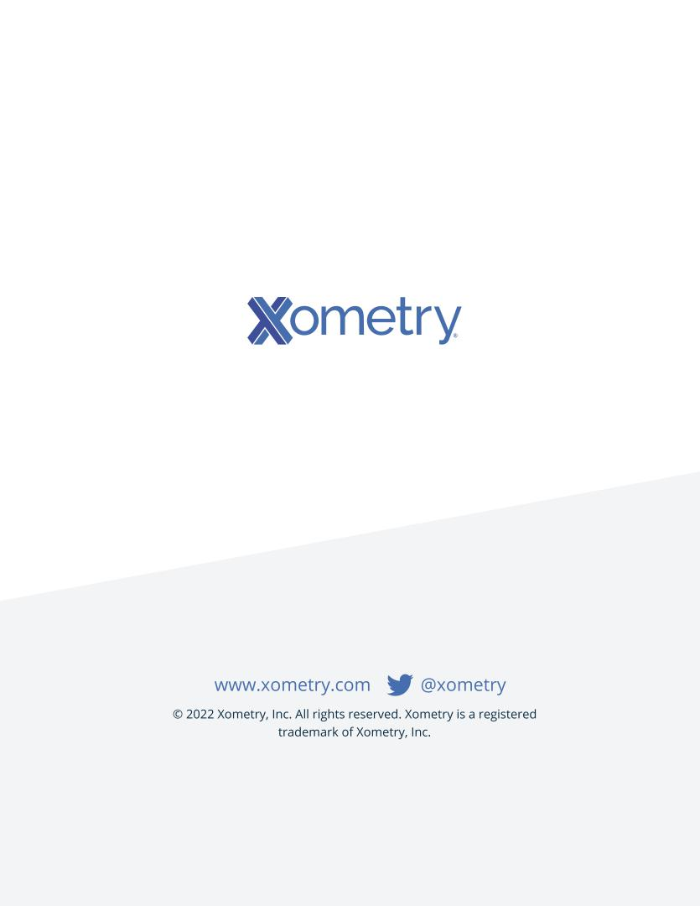

Table of Contents
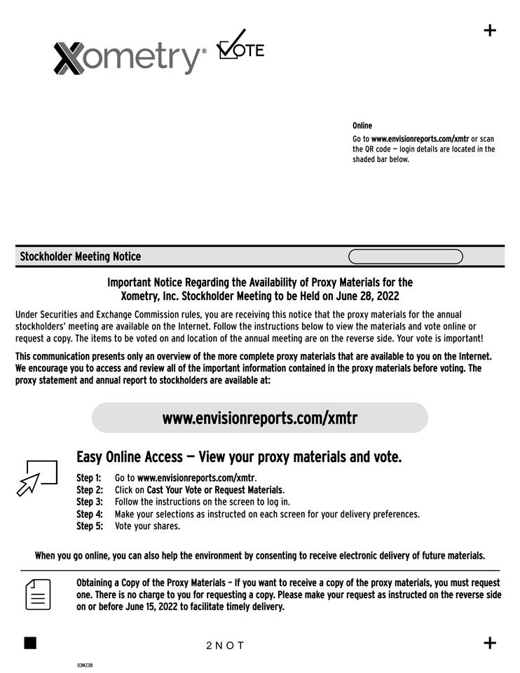

Table of Contents
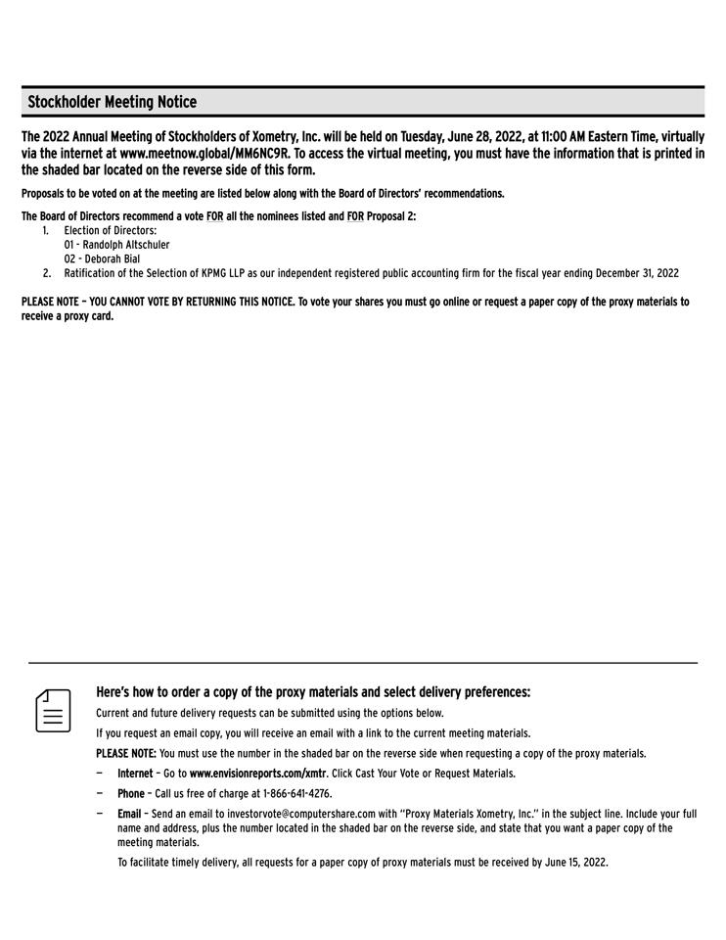

Table of Contents
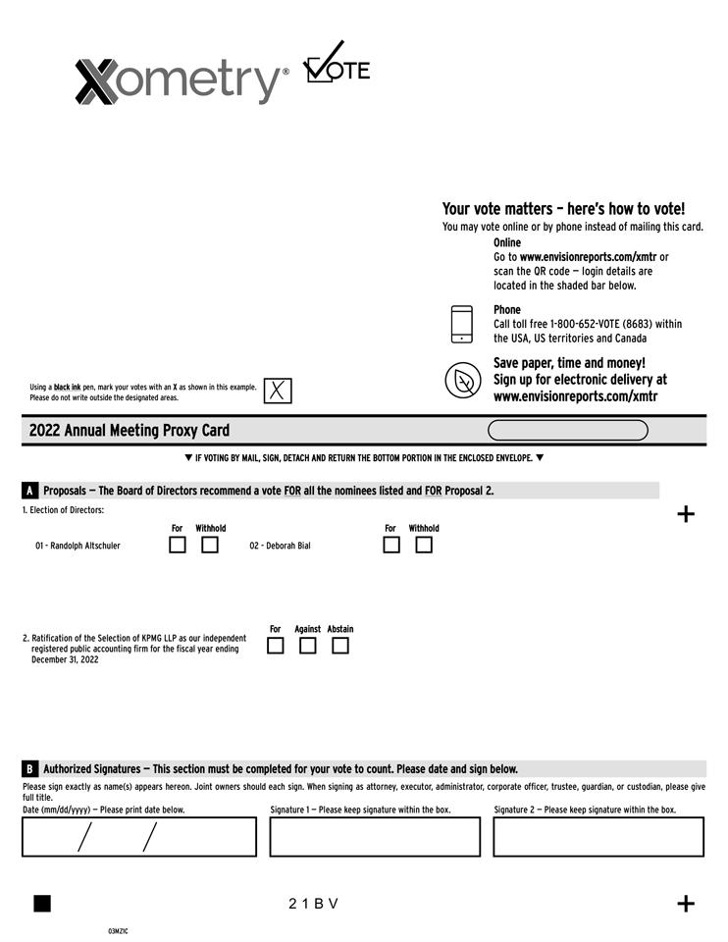

Table of Contents
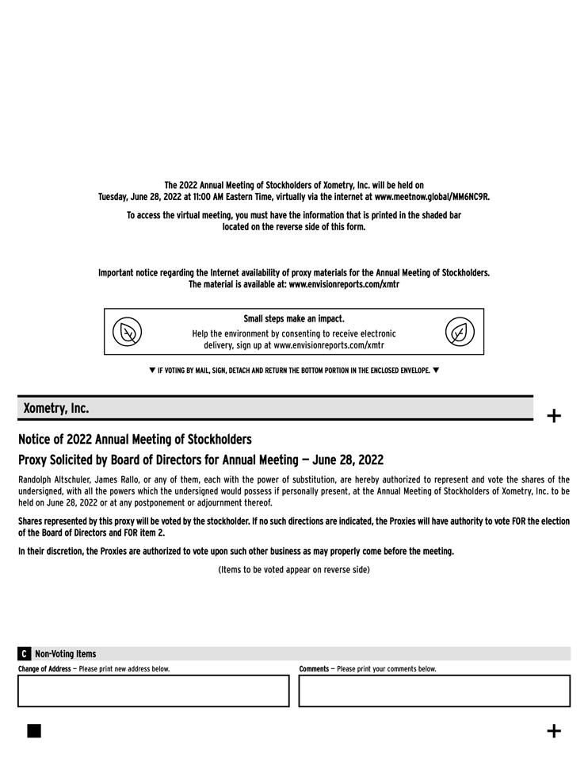

Table of Contents
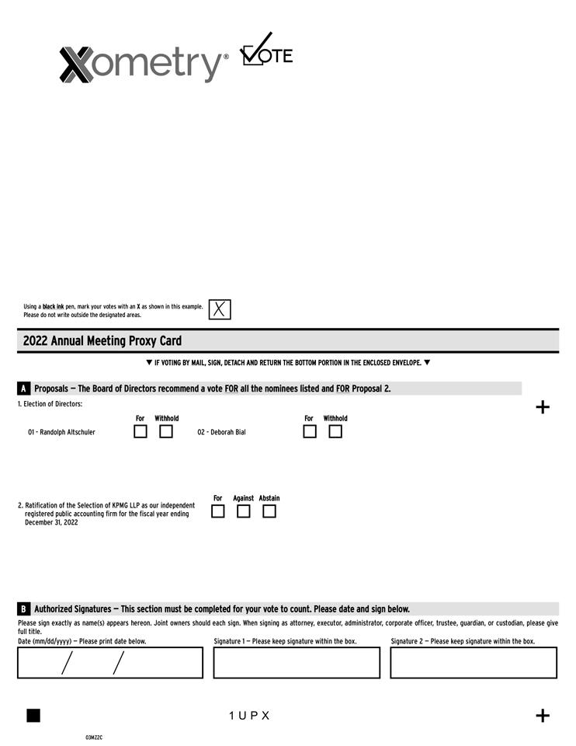

Table of Contents


